**短线趋势跟踪-指数关联影响研究**

回测2年数据（20160831-20180831，489个交易日，沪深300涨0.68% ），光头光脚阳线，且相对前日缩量，排除新股和涨停板。

# 赢利超过10%

## 厦门国贸

|  |  |  |  |
| --- | --- | --- | --- |
| 2017/7/18 | 600755 | 厦门国贸 | **35.94%** |

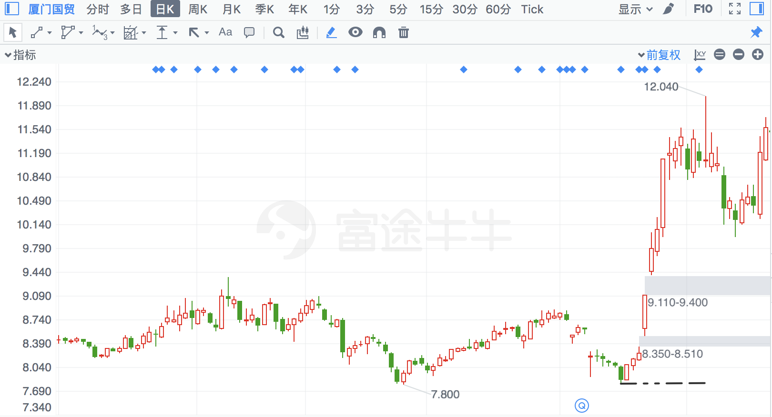

## 海辰药业

|  |  |  |  |
| --- | --- | --- | --- |
| 2018/3/26 | 300584 | 海辰药业 | **34.07%** |

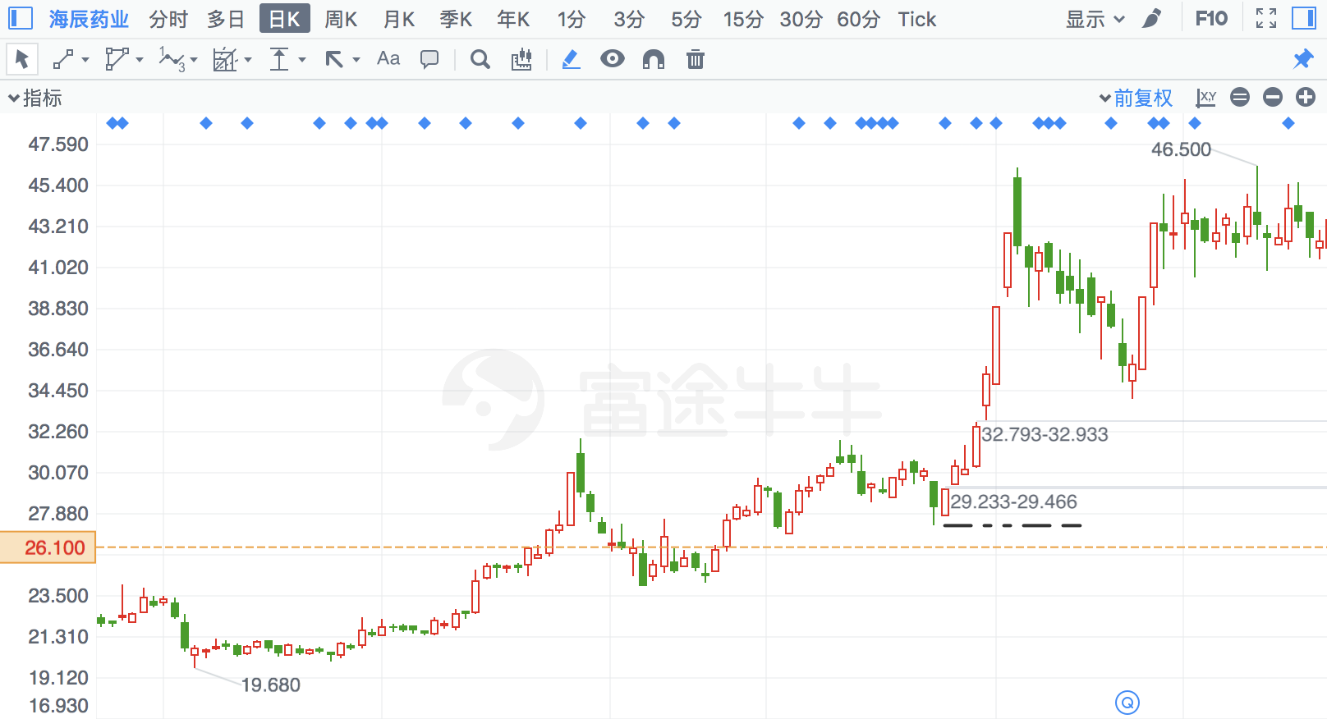

## 正元智慧

|  |  |  |  |
| --- | --- | --- | --- |
| 2017/8/3 | 300645 | 正元智慧 | **28.73%** |

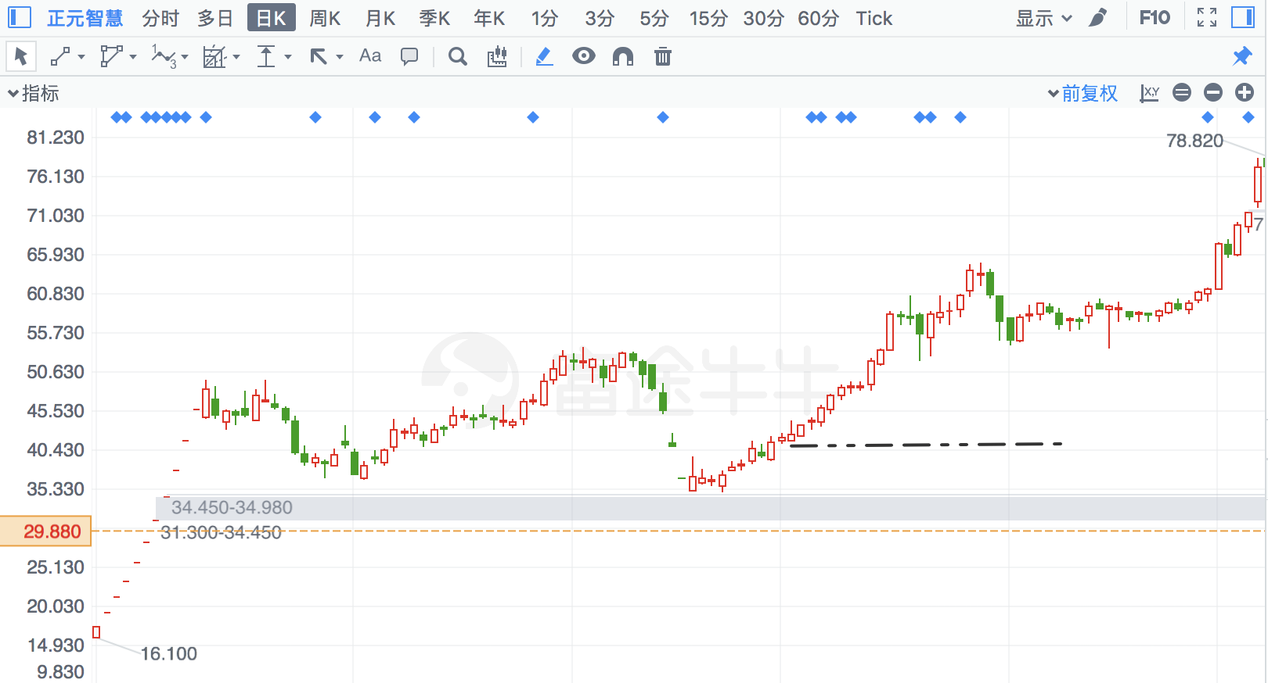

## 五洋停车

|  |  |  |  |
| --- | --- | --- | --- |
| 2018/2/22 | 300420 | 五洋停车 | **25.91%** |

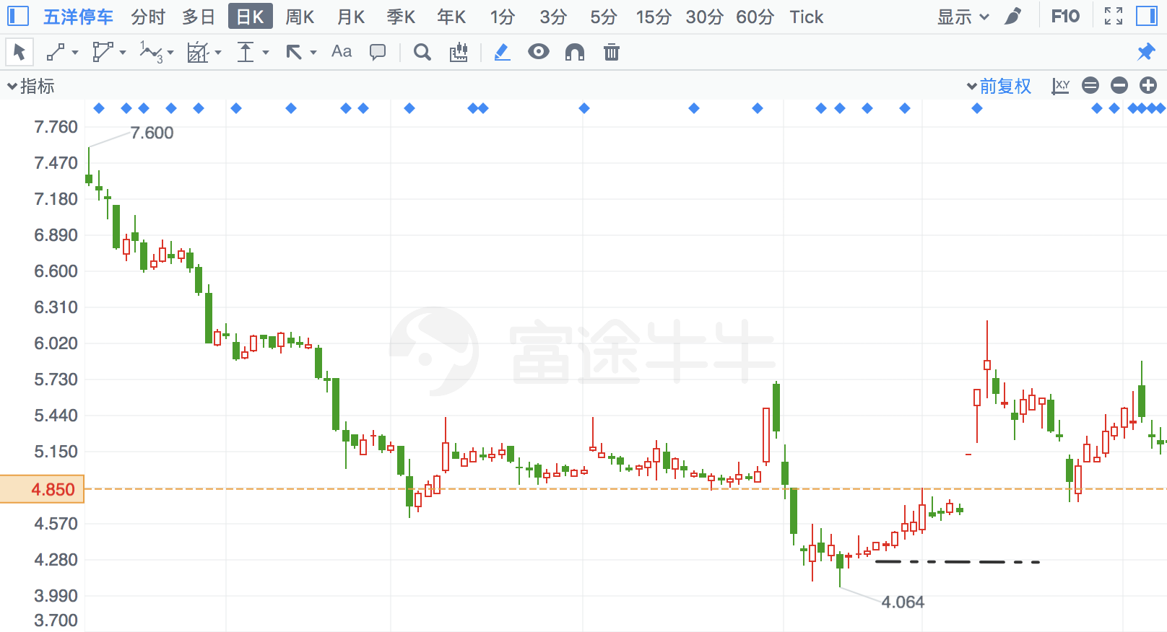

## *ST宜化

|  |  |  |  |
| --- | --- | --- | --- |
| 2018/7/9 | 422 | *ST宜化 | **25.74%** |

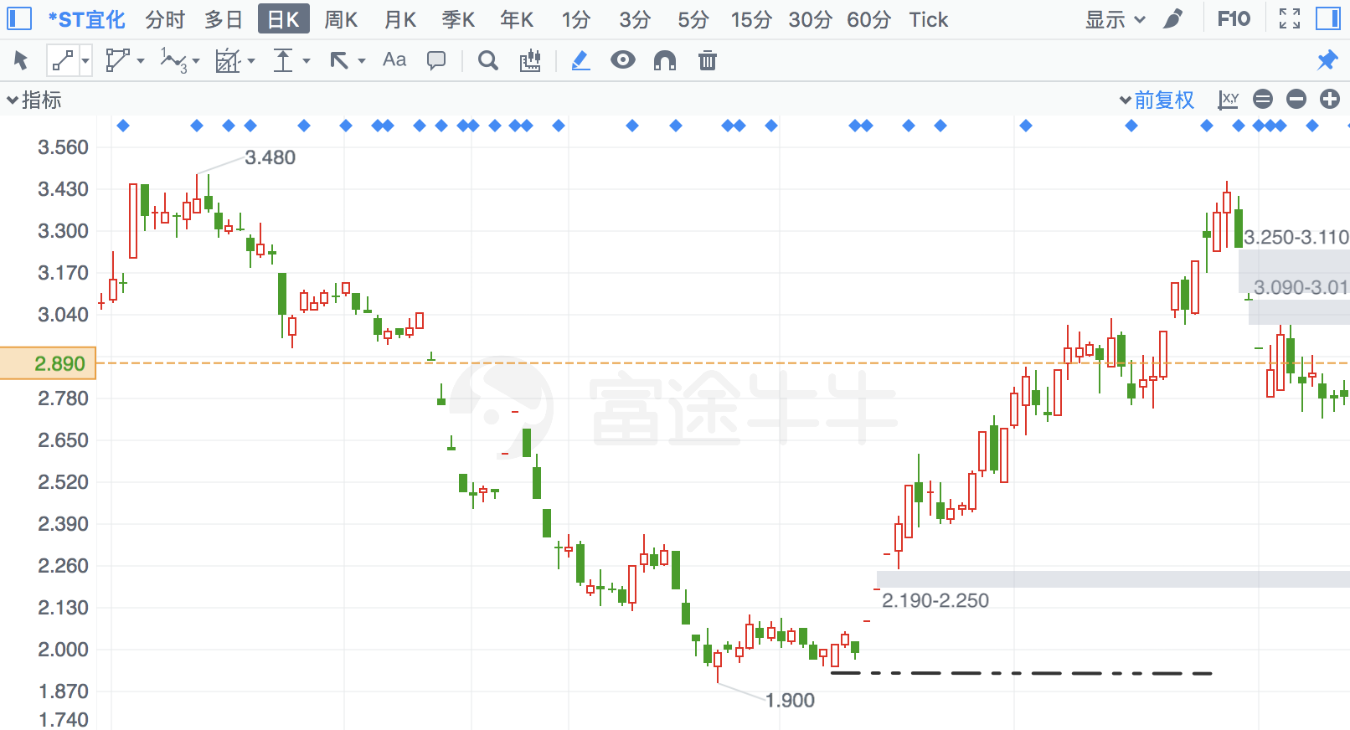

## ST昌九

|  |  |  |  |
| --- | --- | --- | --- |
| 2017/9/27 | 600228 | ST昌九 | **25.64%** |

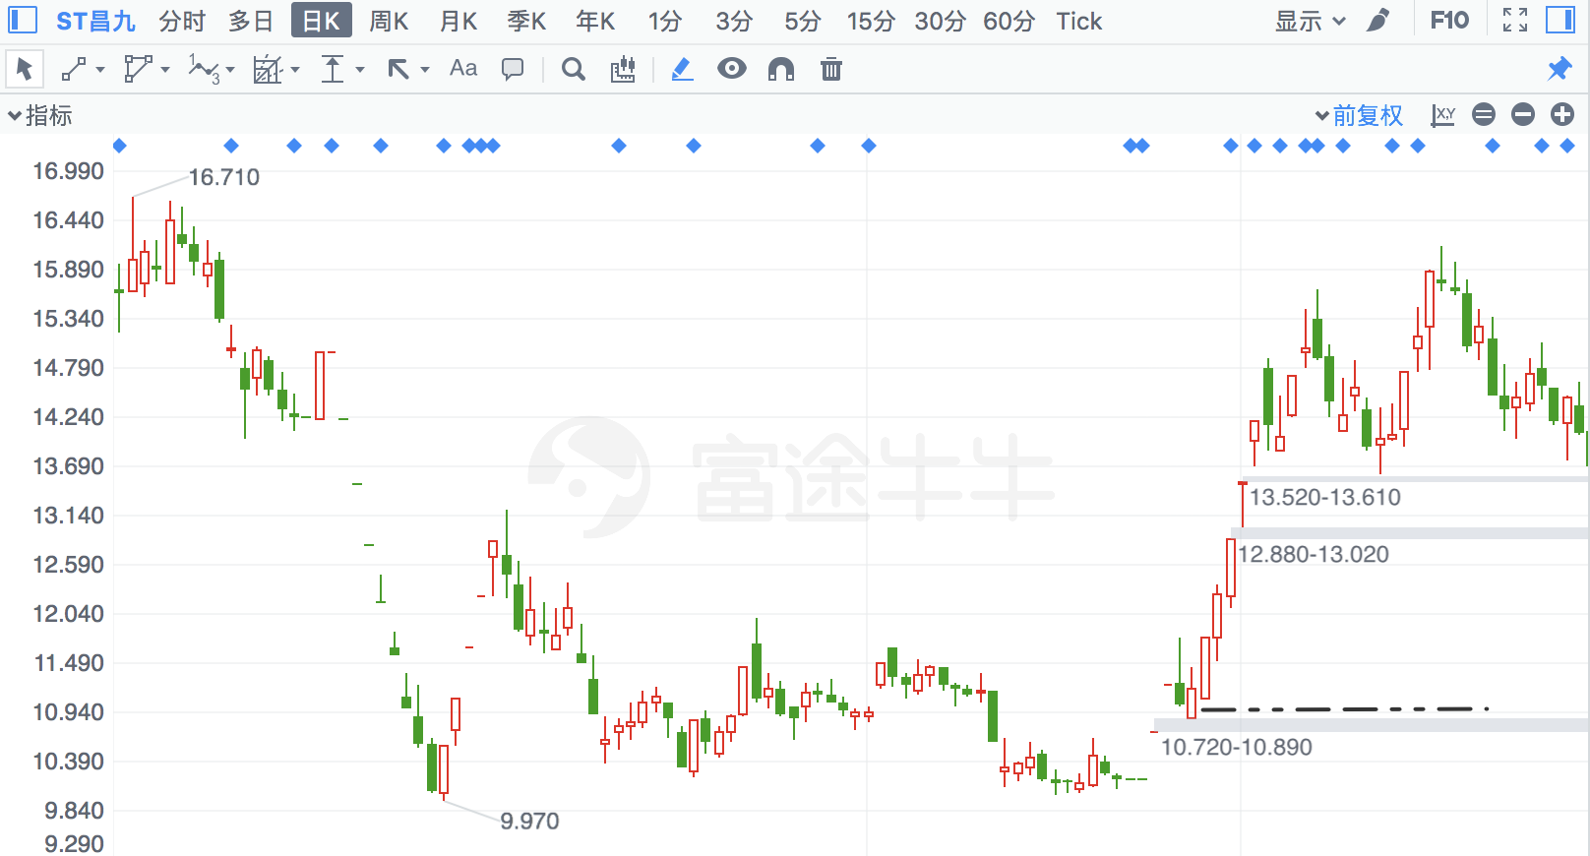

## 和仁科技

|  |  |  |  |
| --- | --- | --- | --- |
| 2018/2/8 | 300550 | 和仁科技 | **19.99%** |

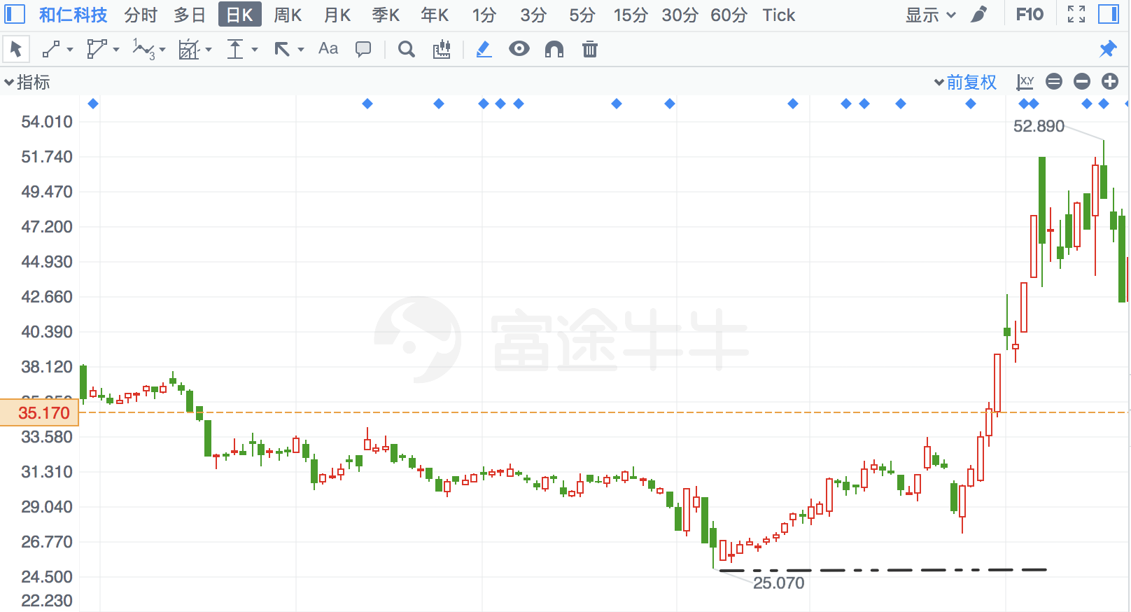

## 华联股份

|  |  |  |  |
| --- | --- | --- | --- |
| 2018/2/8 | 882 | 华联股份 | **19.05%** |

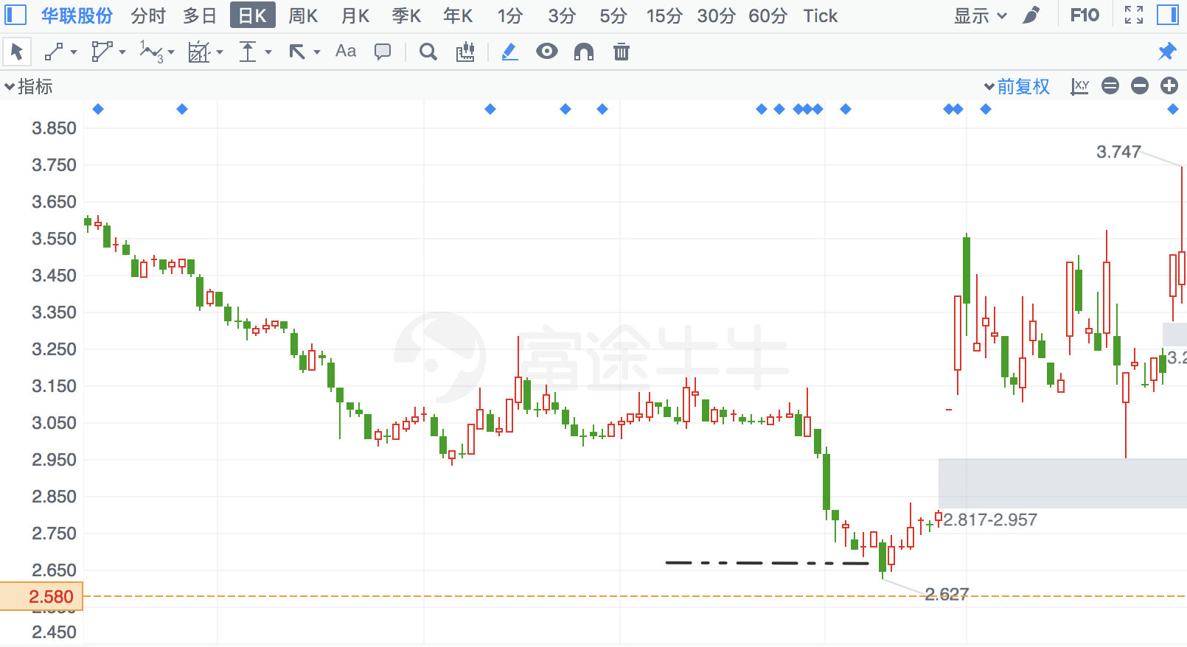

## 梦洁股份

|  |  |  |  |
| --- | --- | --- | --- |
| 2017/11/28 | 2397 | 梦洁股份 | **18.38%** |

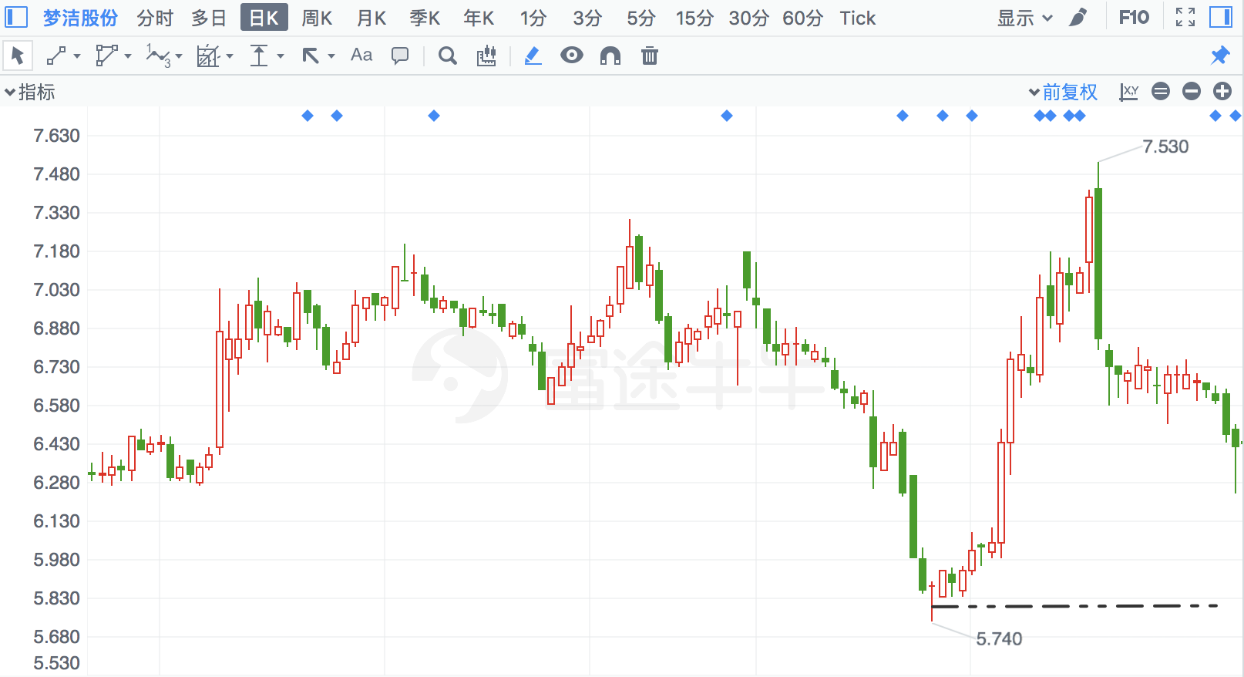

## 重庆钢铁

|  |  |  |  |
| --- | --- | --- | --- |
| 2017/6/14 | 601005 | 重庆钢铁 | **18.07%** |

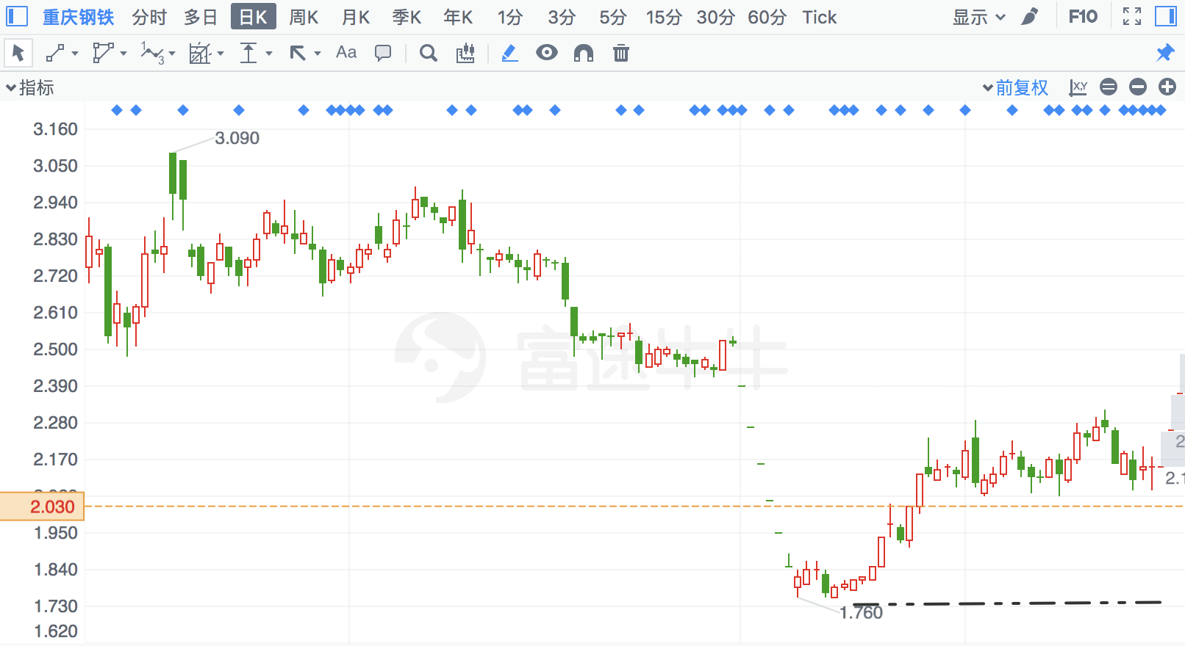

## 恒星科技

|  |  |  |  |
| --- | --- | --- | --- |
| 2016/9/13 | 2132 | 恒星科技 | **16.97%** |

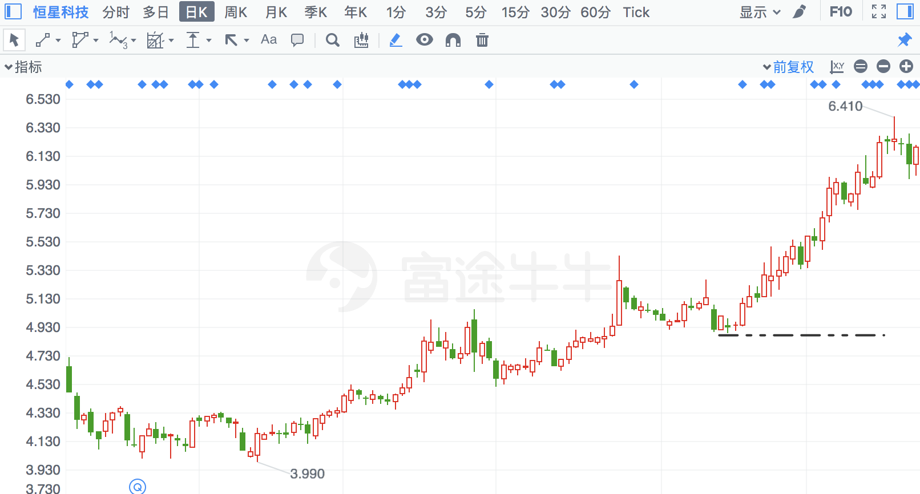

## 蓝丰生化

|  |  |  |  |
| --- | --- | --- | --- |
| 2018/2/8 | 2513 | 蓝丰生化 | **16.09%** |

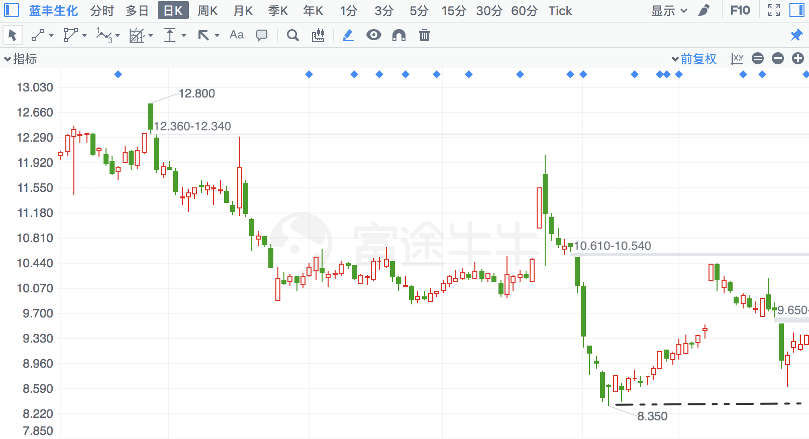

## 光洋股份

|  |  |  |  |
| --- | --- | --- | --- |
| 2017/6/26 | 2708 | 光洋股份 | **14.83%** |

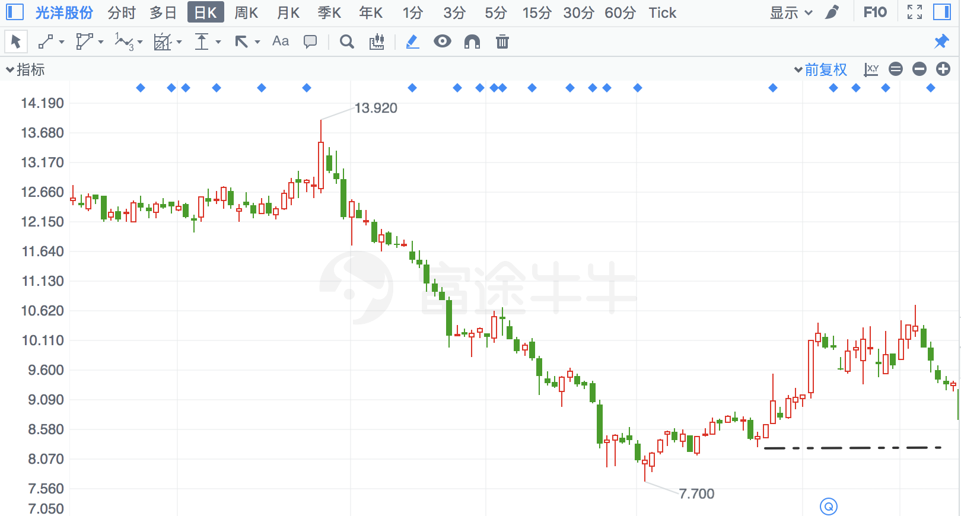

## 中国海诚

|  |  |  |  |
| --- | --- | --- | --- |
| 2017/8/15 | 2116 | 中国海诚 | **14.45%** |

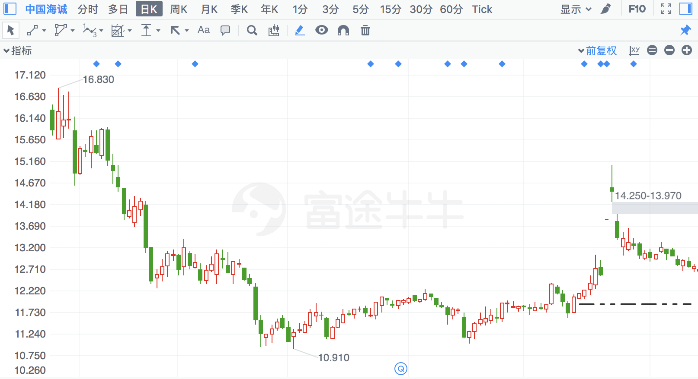

## 甘肃电投

|  |  |  |  |
| --- | --- | --- | --- |
| 2018/2/14 | 791 | 甘肃电投 | **14.31%** |

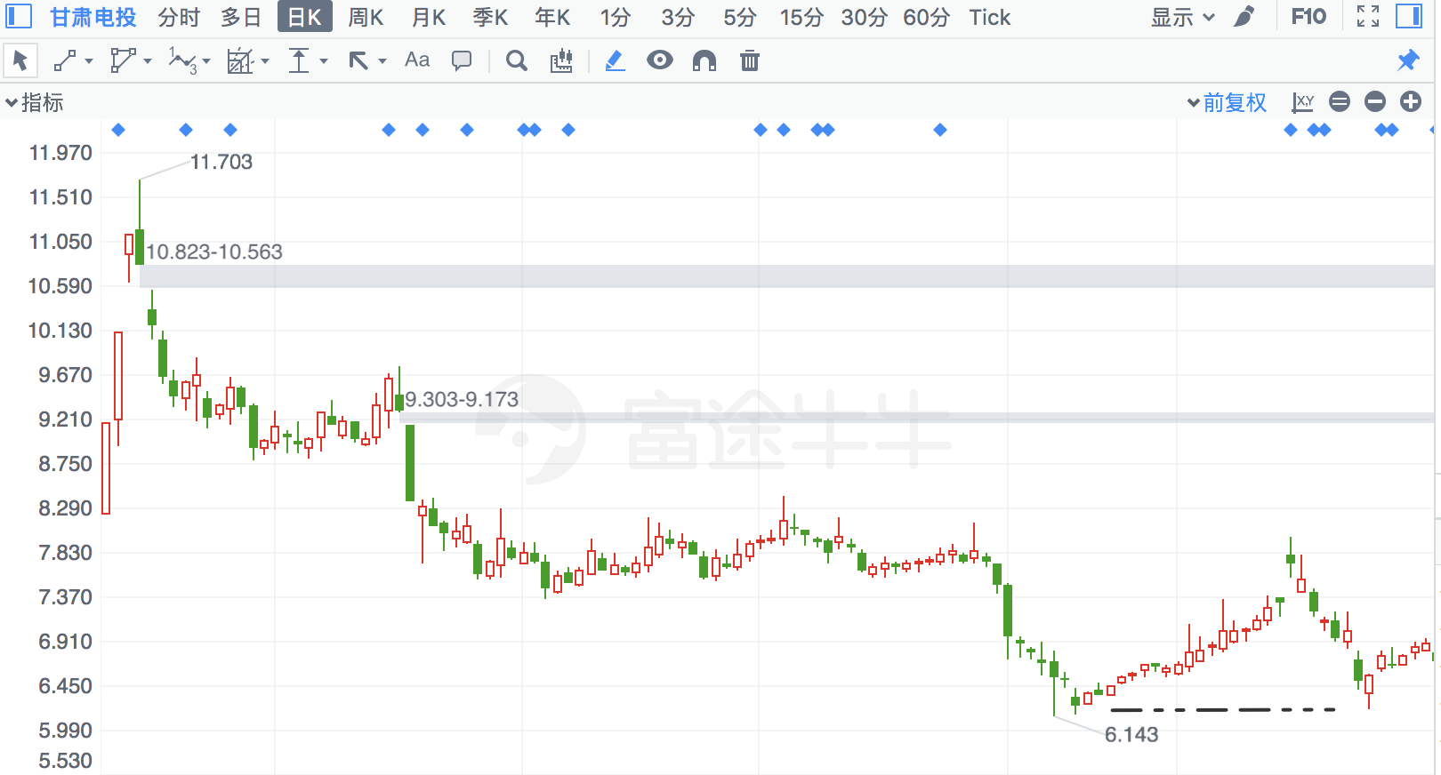

## 中际旭创

|  |  |  |  |
| --- | --- | --- | --- |
| 2018/2/23 | 300308 | 中际旭创 | **14.27%** |

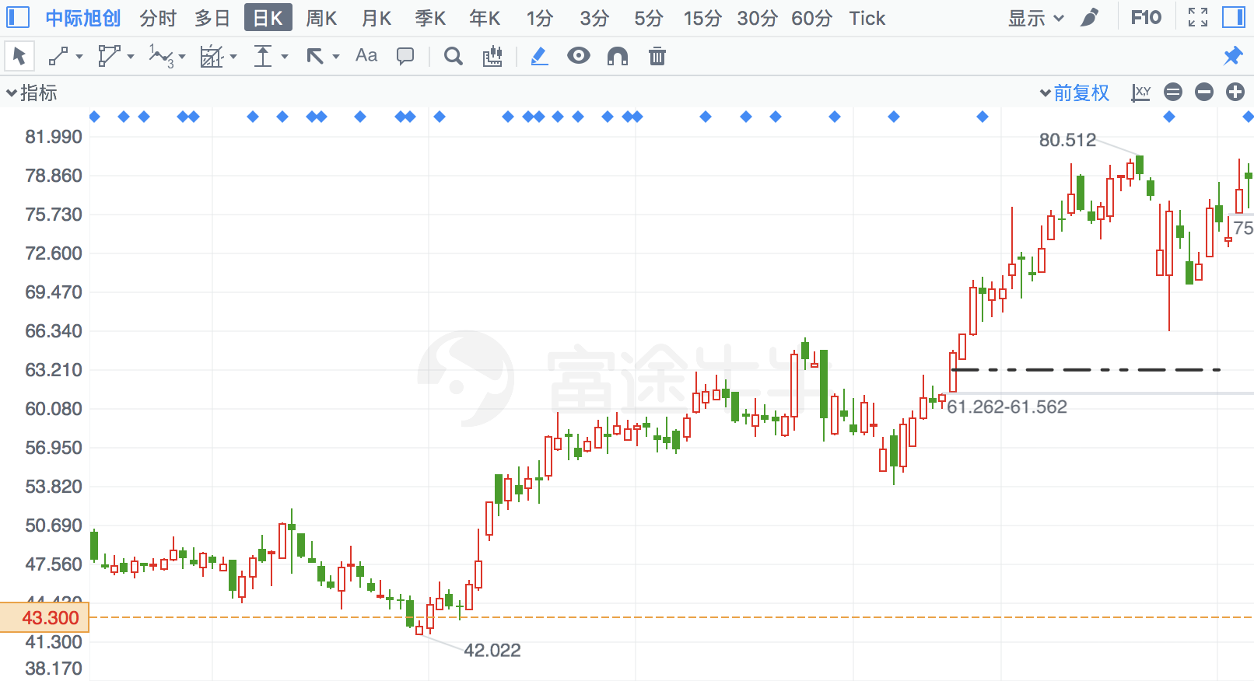

## 涪陵榨菜

|  |  |  |  |
| --- | --- | --- | --- |
| 2018/4/27 | 2507 | 涪陵榨菜 | **14.16%** |

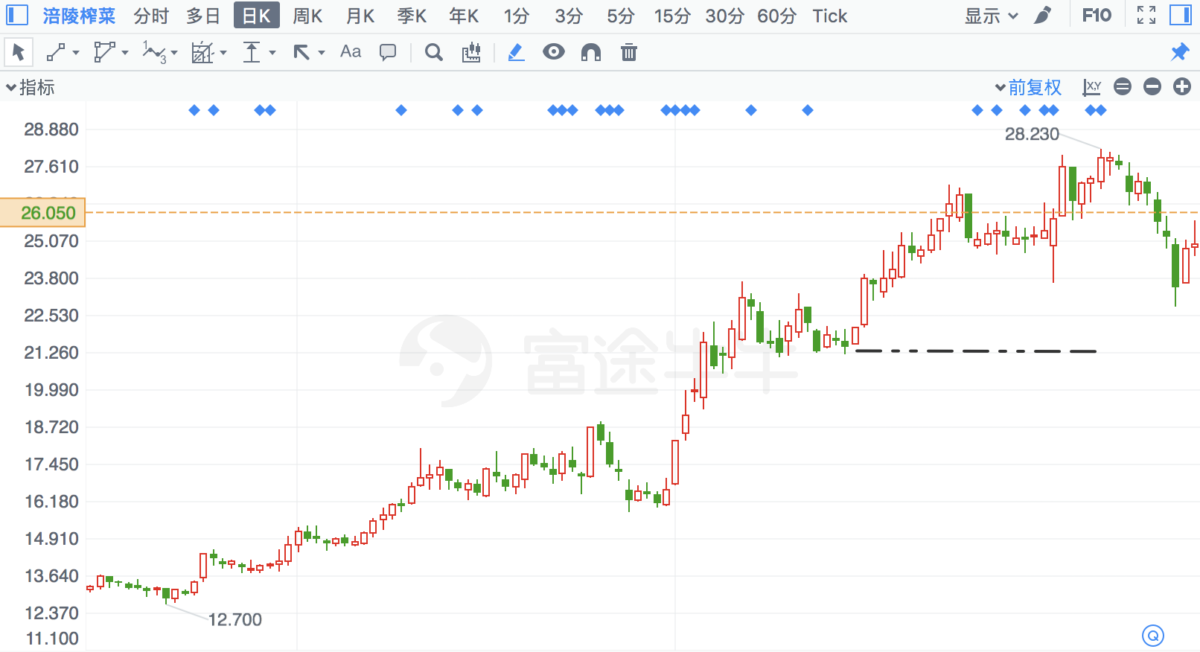

## 博晖创新

|  |  |  |  |
| --- | --- | --- | --- |
| 2017/8/31 | 300318 | 博晖创新 | **13.98%** |

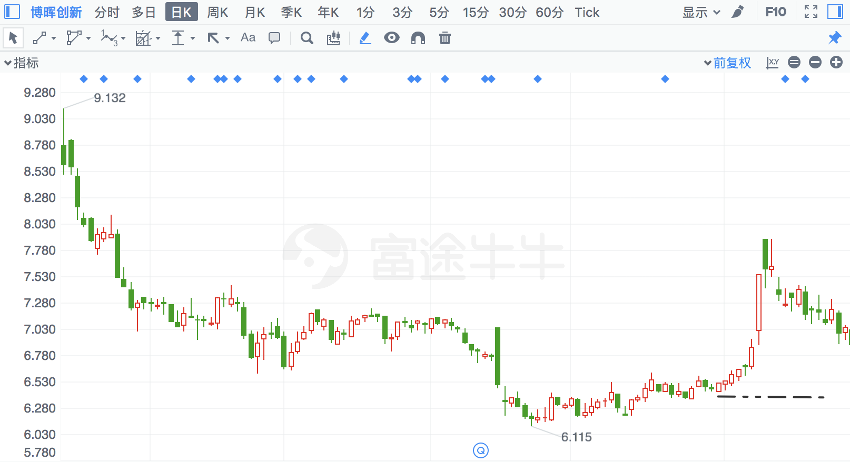

## 高乐股份

|  |  |  |  |
| --- | --- | --- | --- |
| 2018/2/8 | 2348 | 高乐股份 | **13.80%** |

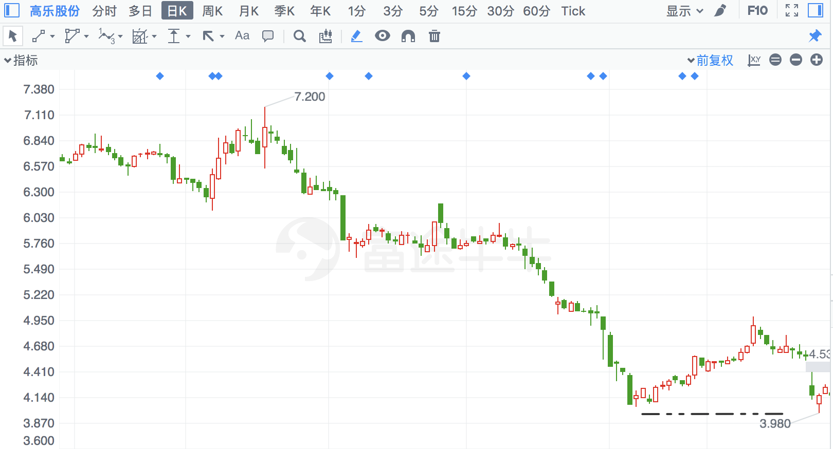

## 仙琚制药

|  |  |  |  |
| --- | --- | --- | --- |
| 2016/9/27 | 2332 | 仙琚制药 | **13.66%** |

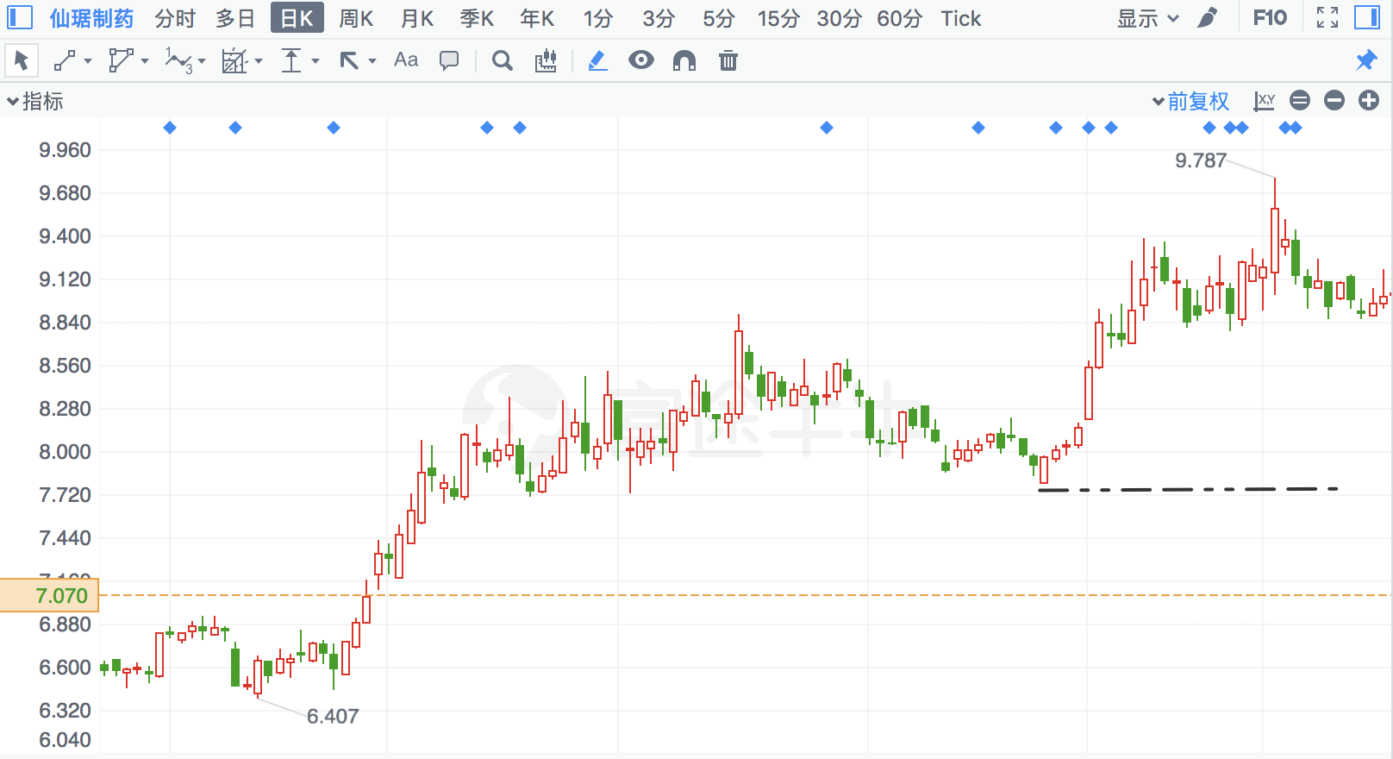

## 秀强股份

|  |  |  |  |
| --- | --- | --- | --- |
| 2018/7/20 | 300160 | 秀强股份 | **13.64%** |

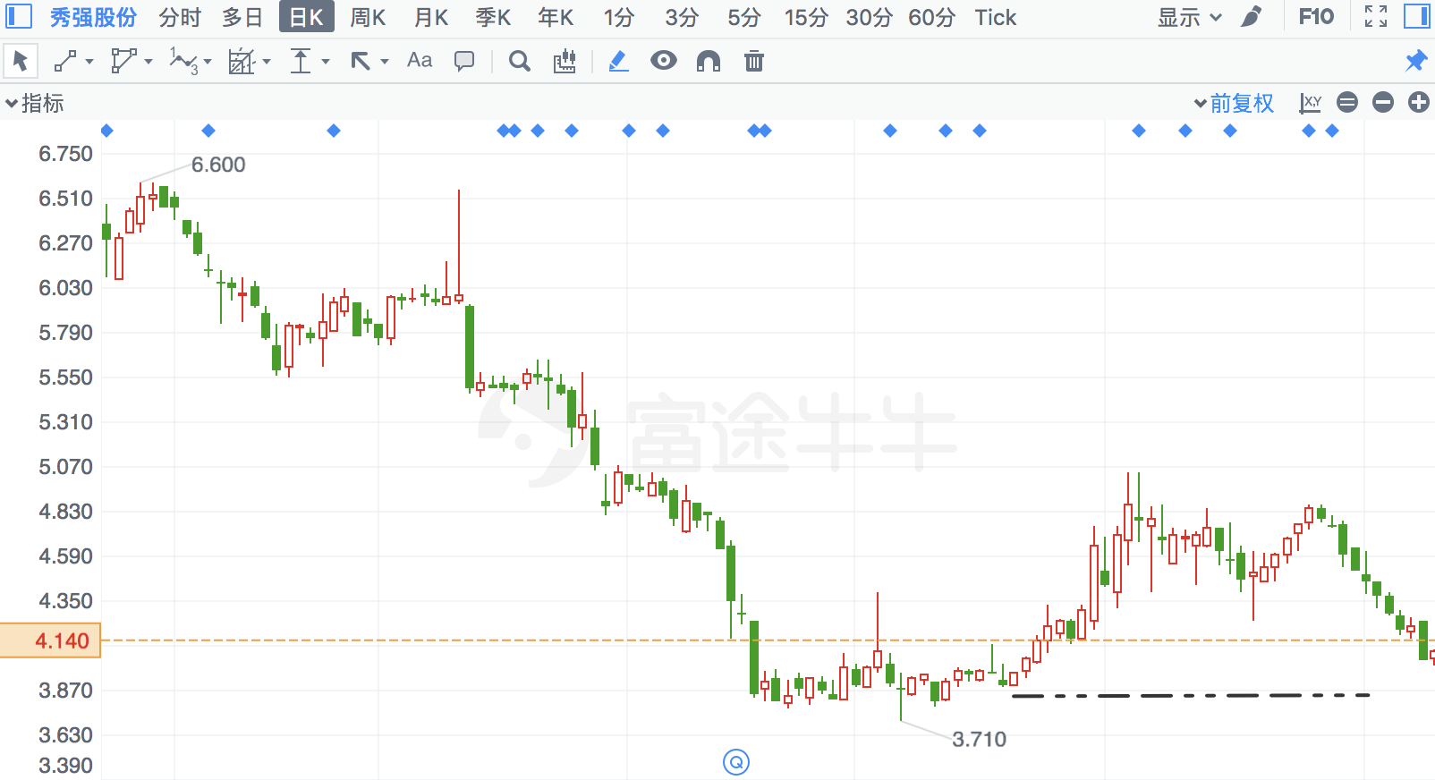

## *ST尤夫

|  |  |  |  |
| --- | --- | --- | --- |
| 2018/8/23 | 2427 | *ST尤夫 | **13.46%** |

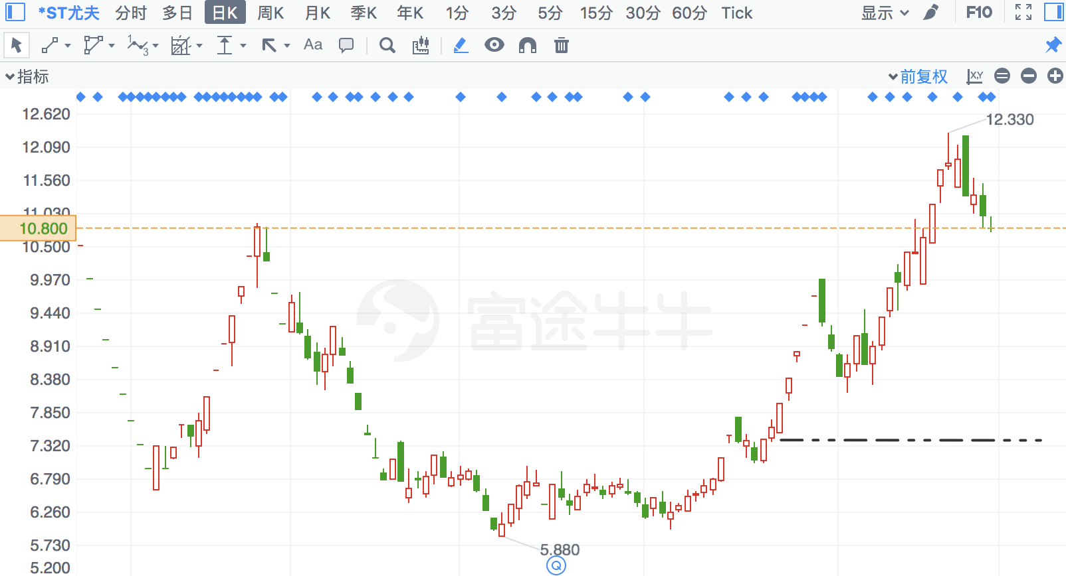

## 华锦股份

|  |  |  |  |
| --- | --- | --- | --- |
| 2017/7/18 | 59 | 华锦股份 | **13.00%** |

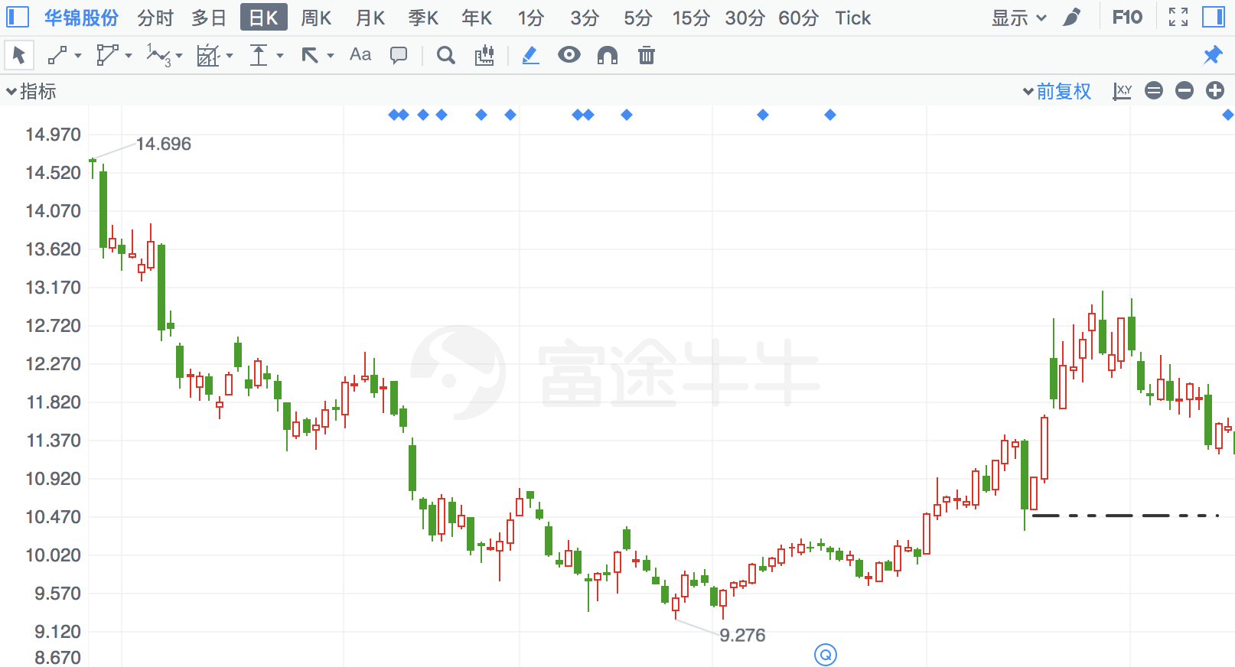

## 赛轮金宇

|  |  |  |  |
| --- | --- | --- | --- |
| 2018/4/27 | 601058 | 赛轮金宇 | **12.59%** |

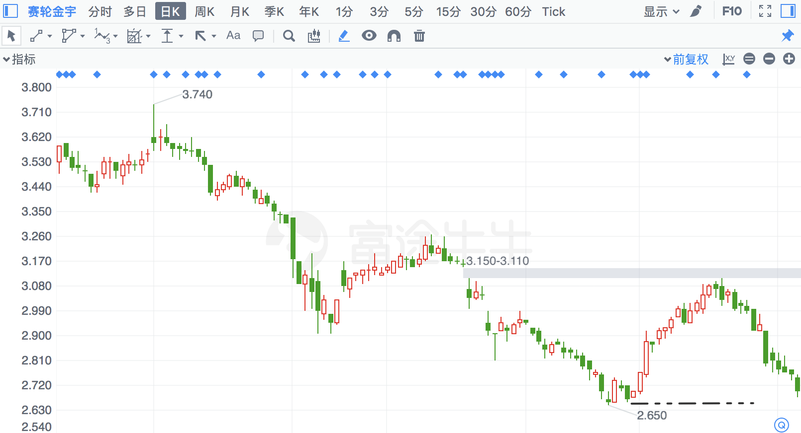

## ST云维

|  |  |  |  |
| --- | --- | --- | --- |
| 2018/2/12 | 600725 | ST云维 | **12.50%** |

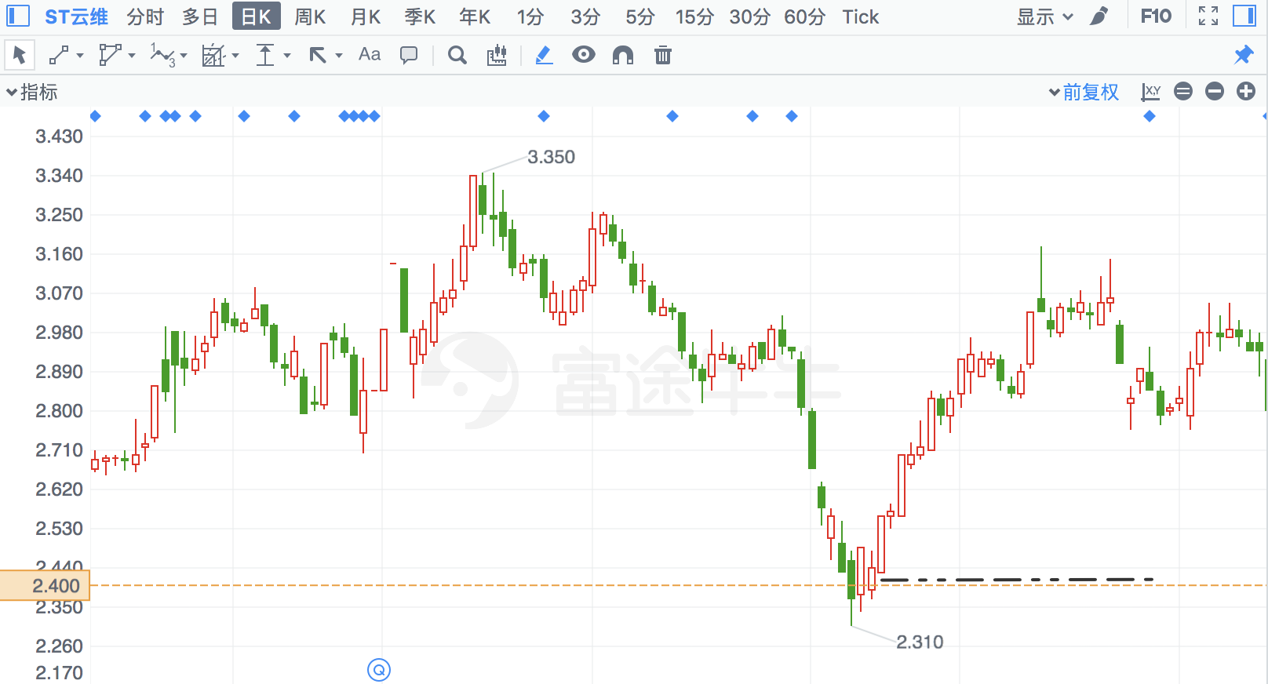

## 光一科技

|  |  |  |  |
| --- | --- | --- | --- |
| 2016/11/11 | 300356 | 光一科技 | **12.48%** |

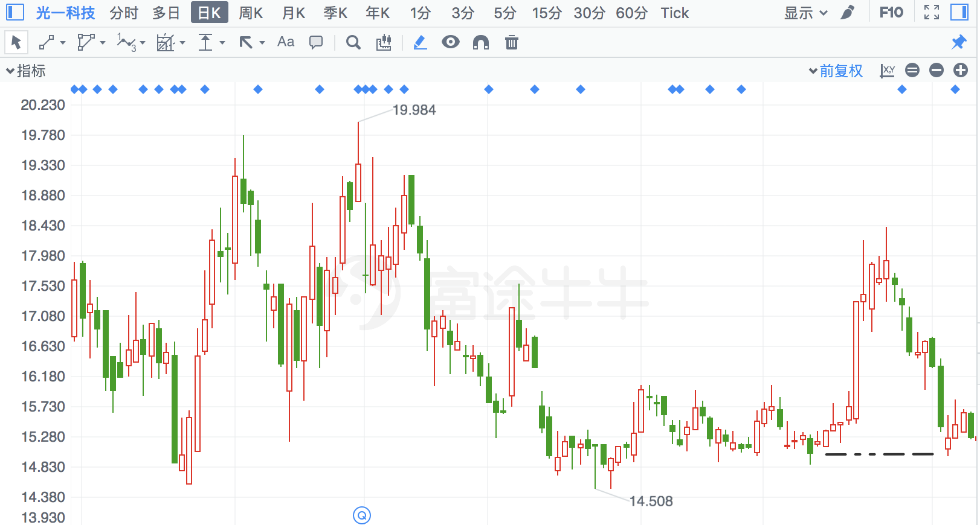

## 海得控制

|  |  |  |  |
| --- | --- | --- | --- |
| 2017/8/25 | 2184 | 海得控制 | **12.10%** |

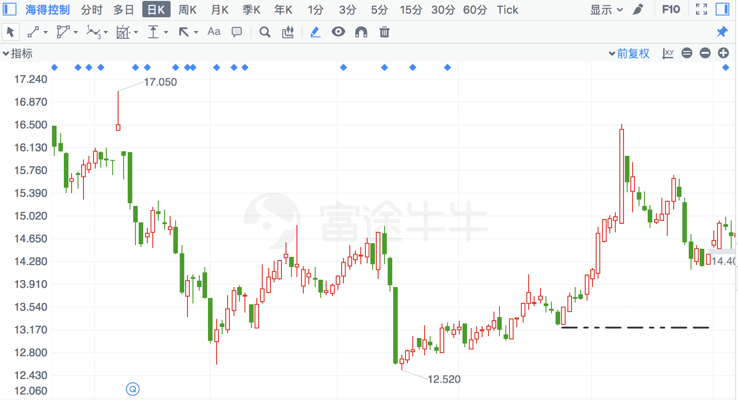

## 三泰控股

|  |  |  |  |
| --- | --- | --- | --- |
| 2017/8/14 | 2312 | 三泰控股 | **11.86%** |

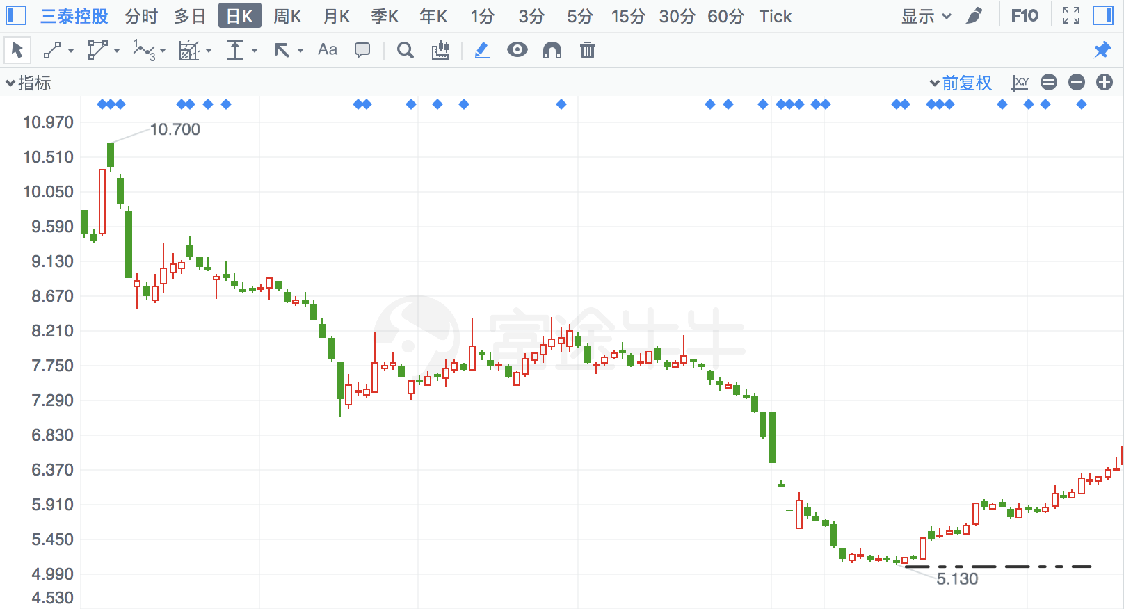

## 世茂股份

|  |  |  |  |
| --- | --- | --- | --- |
| 2017/8/14 | 600823 | 世茂股份 | **11.63%** |

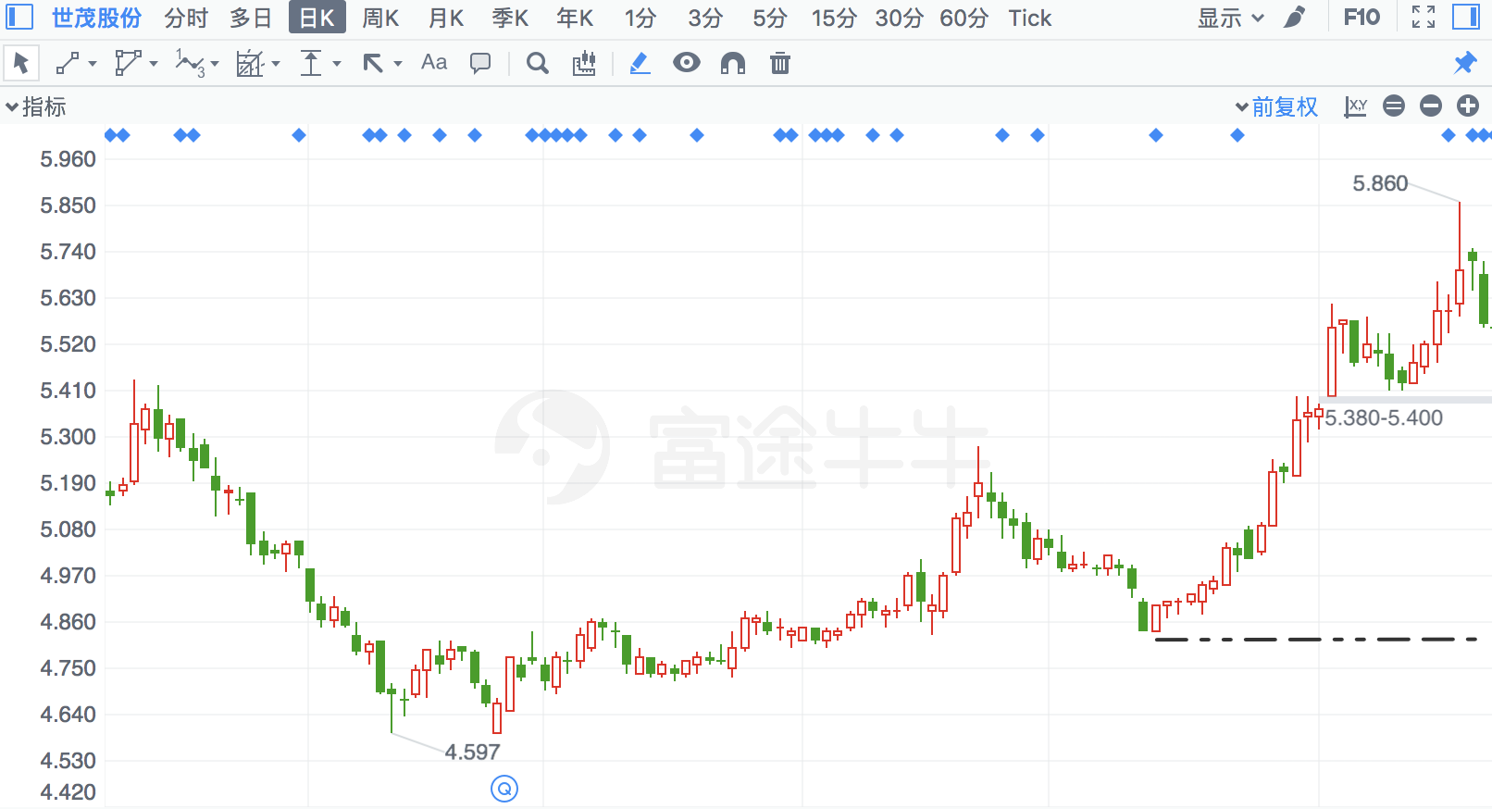

## 大烨智能

|  |  |  |  |
| --- | --- | --- | --- |
| 2018/3/5 | 300670 | 大烨智能 | **11.56%** |

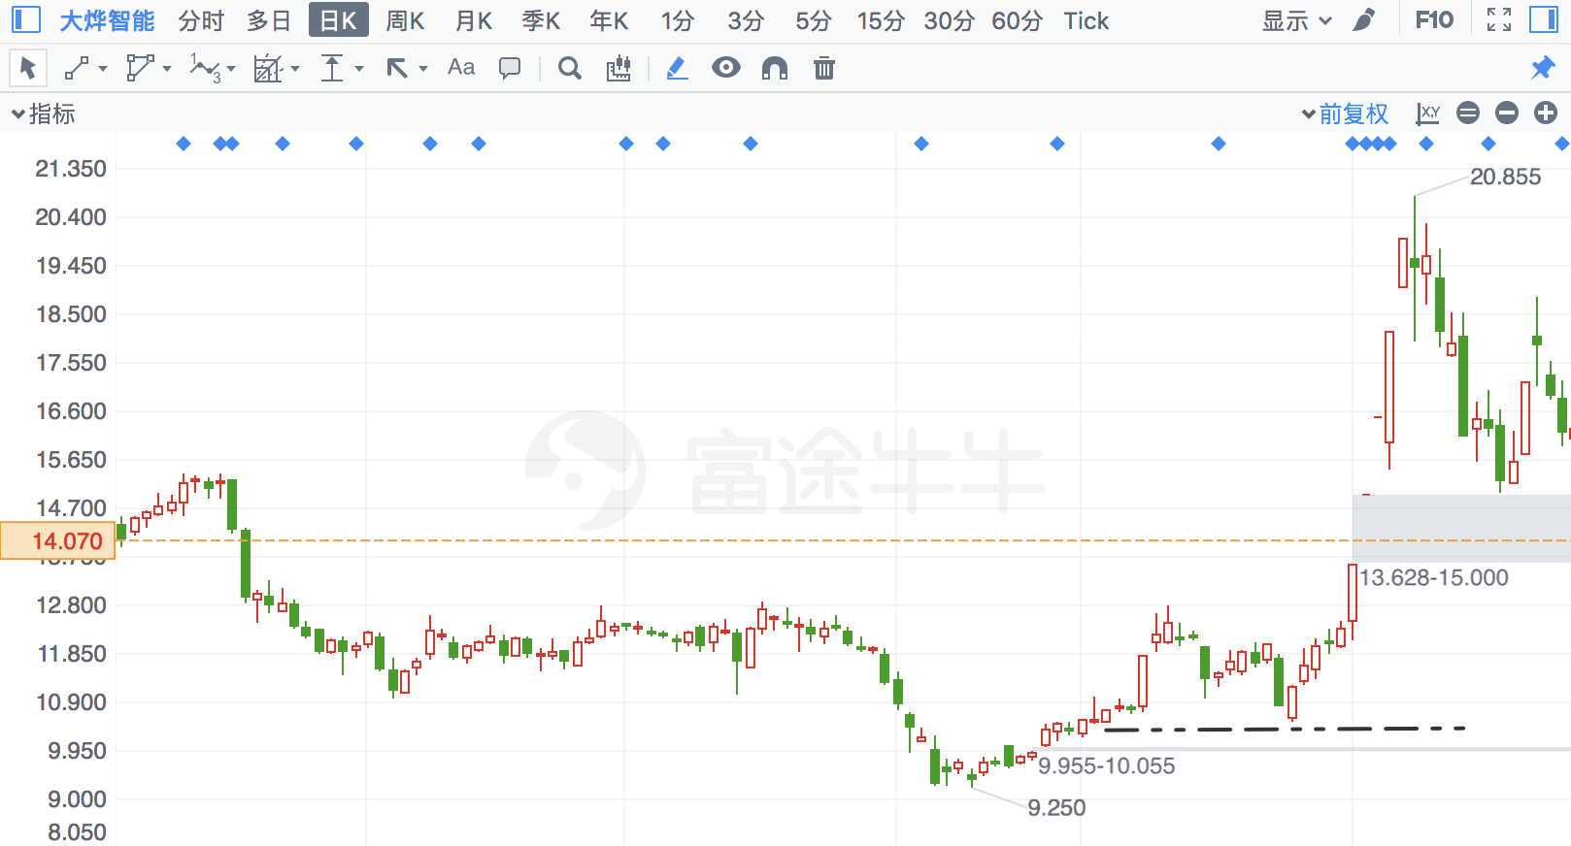

## 秦川机床

|  |  |  |  |
| --- | --- | --- | --- |
| 2018/2/12 | 837 | 秦川机床 | **11.55%** |

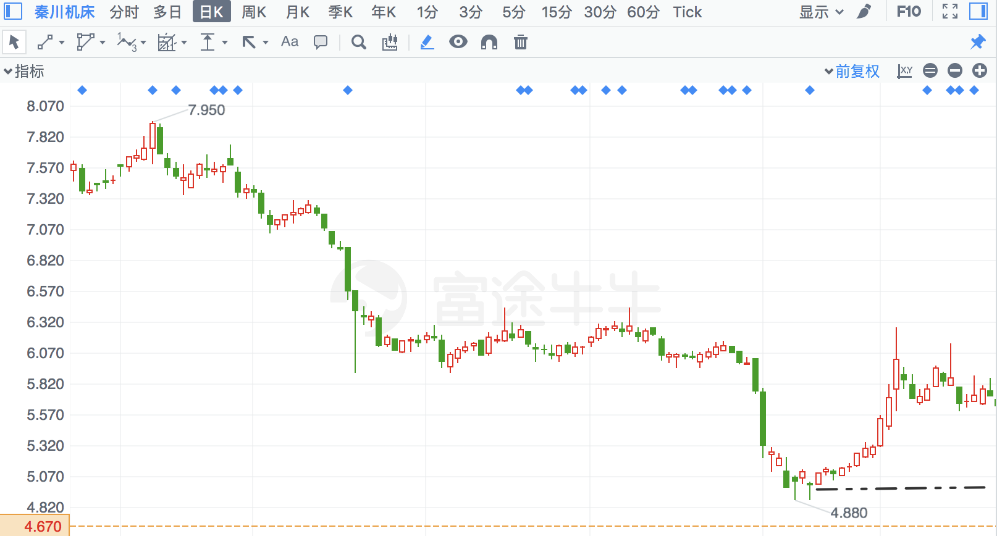

## 齐翔腾达

|  |  |  |  |
| --- | --- | --- | --- |
| 2018/3/26 | 2408 | 齐翔腾达 | **11.54%** |

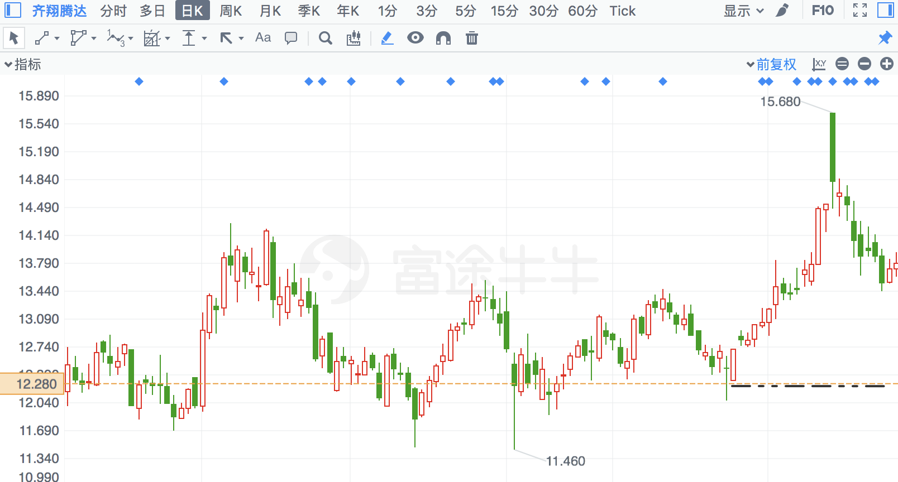

## 汇纳科技

|  |  |  |  |
| --- | --- | --- | --- |
| 2018/3/20 | 300609 | 汇纳科技 | **11.42%** |

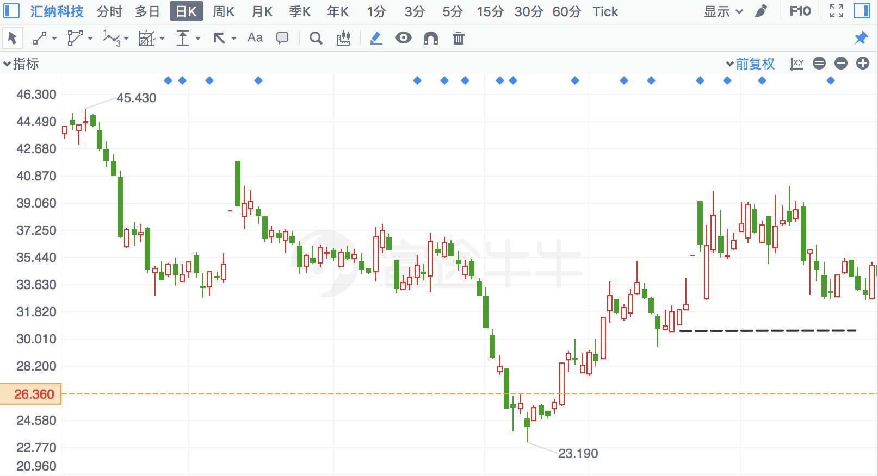

## 京粮控股

|  |  |  |  |
| --- | --- | --- | --- |
| 2016/11/10 | 505 | 京粮控股 | **11.32%** |

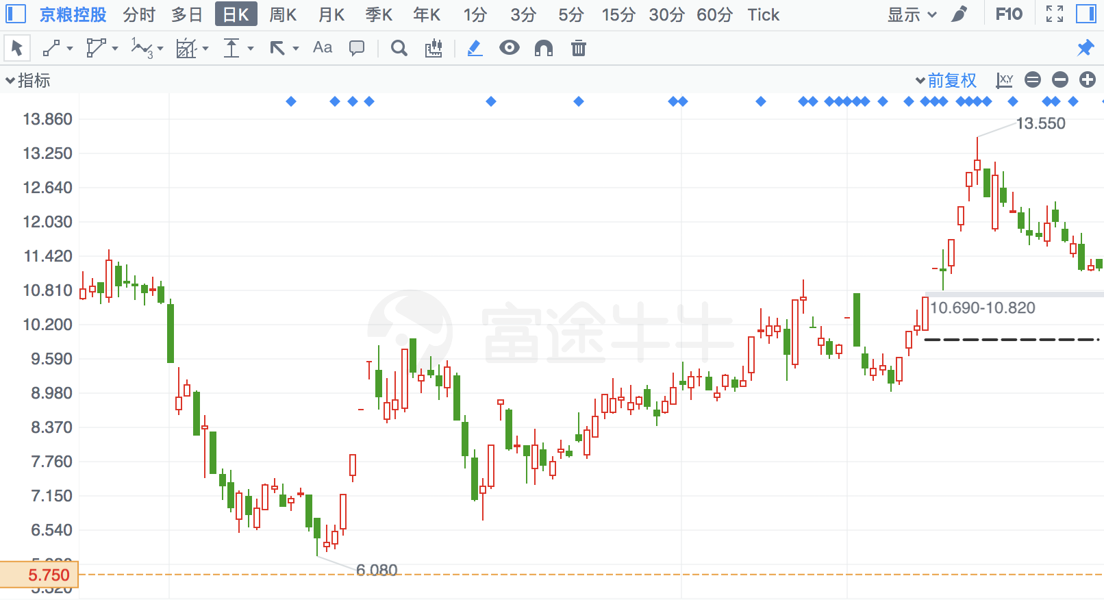

## 乔治白

|  |  |  |  |
| --- | --- | --- | --- |
| 2018/2/8 | 2687 | 乔治白 | **11.19%** |

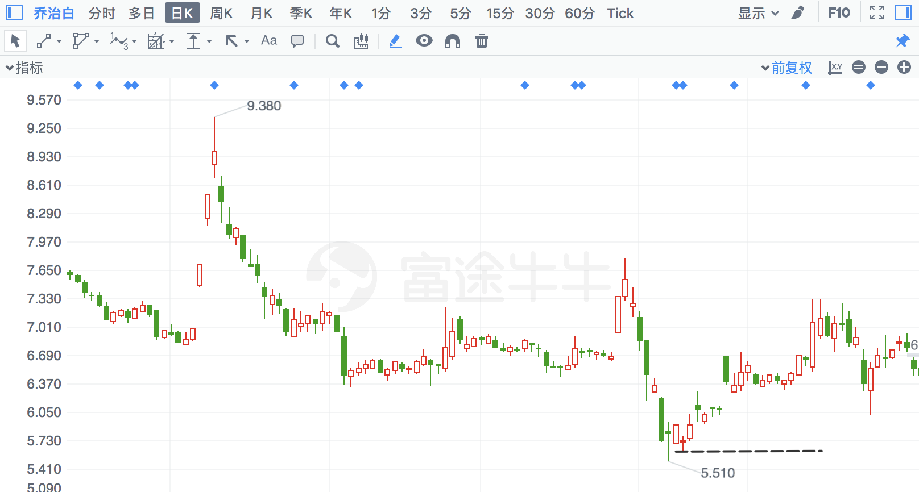

## 麦迪电气

|  |  |  |  |
| --- | --- | --- | --- |
| 2017/1/26 | 300341 | 麦迪电气 | **11.11%** |

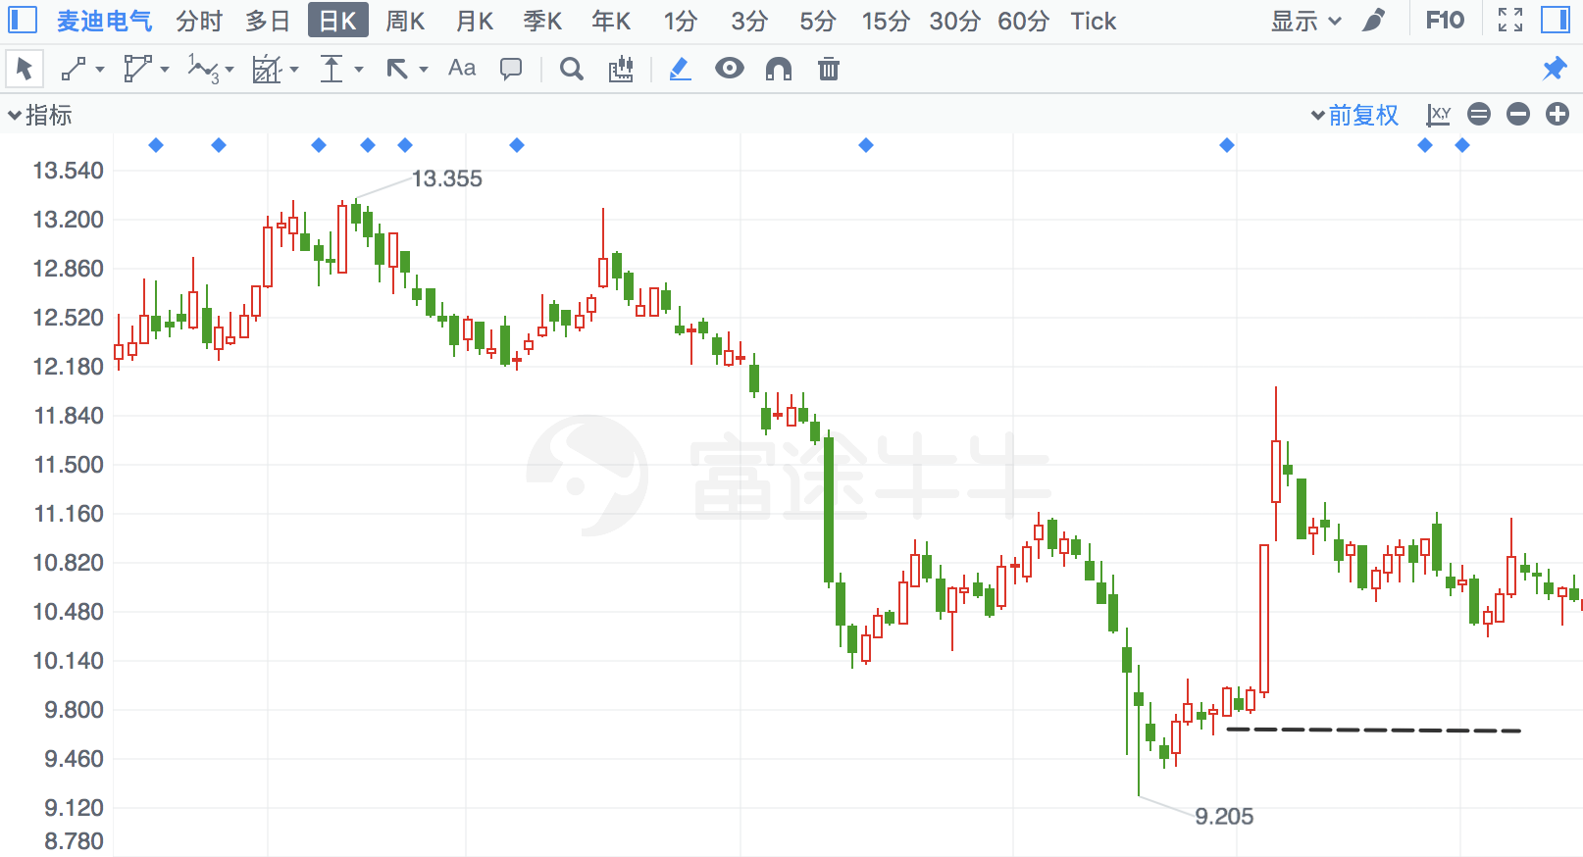

## 电光科技

|  |  |  |  |
| --- | --- | --- | --- |
| 2018/2/9 | 2730 | 电光科技 | **11.02%** |

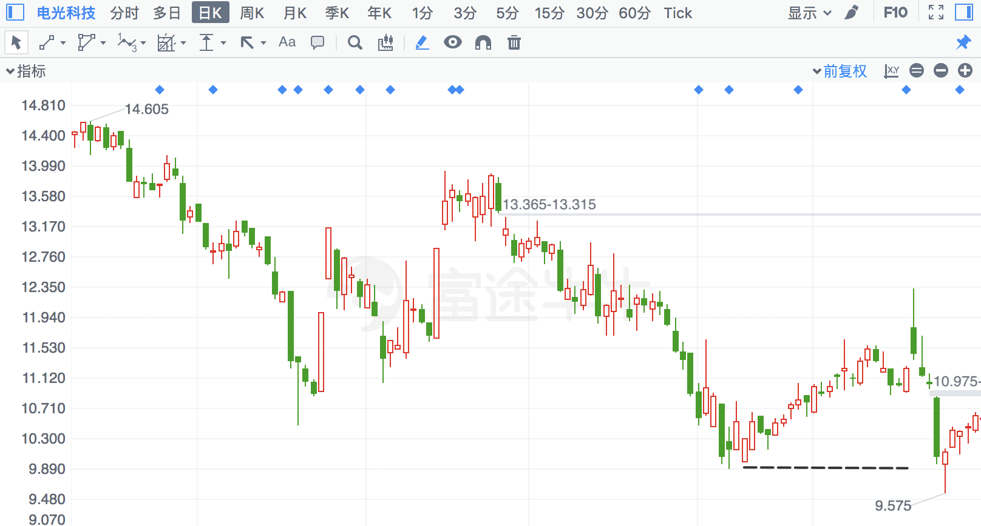

## 云赛智联

|  |  |  |  |
| --- | --- | --- | --- |
| 2018/3/26 | 600602 | 云赛智联 | **10.85%** |

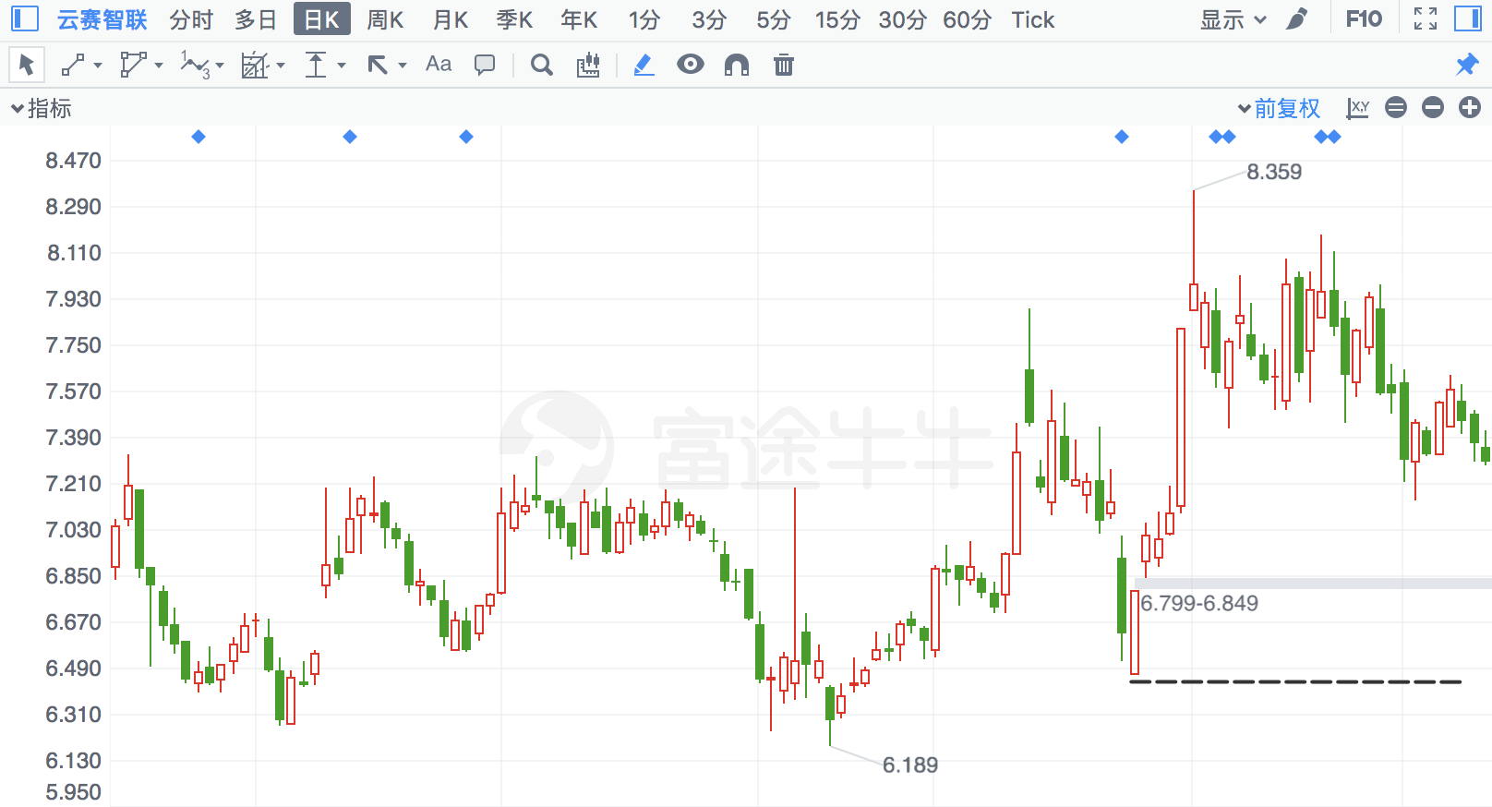

## 华统股份

|  |  |  |  |
| --- | --- | --- | --- |
| 2018/4/24 | 2840 | 华统股份 | **10.81%** |

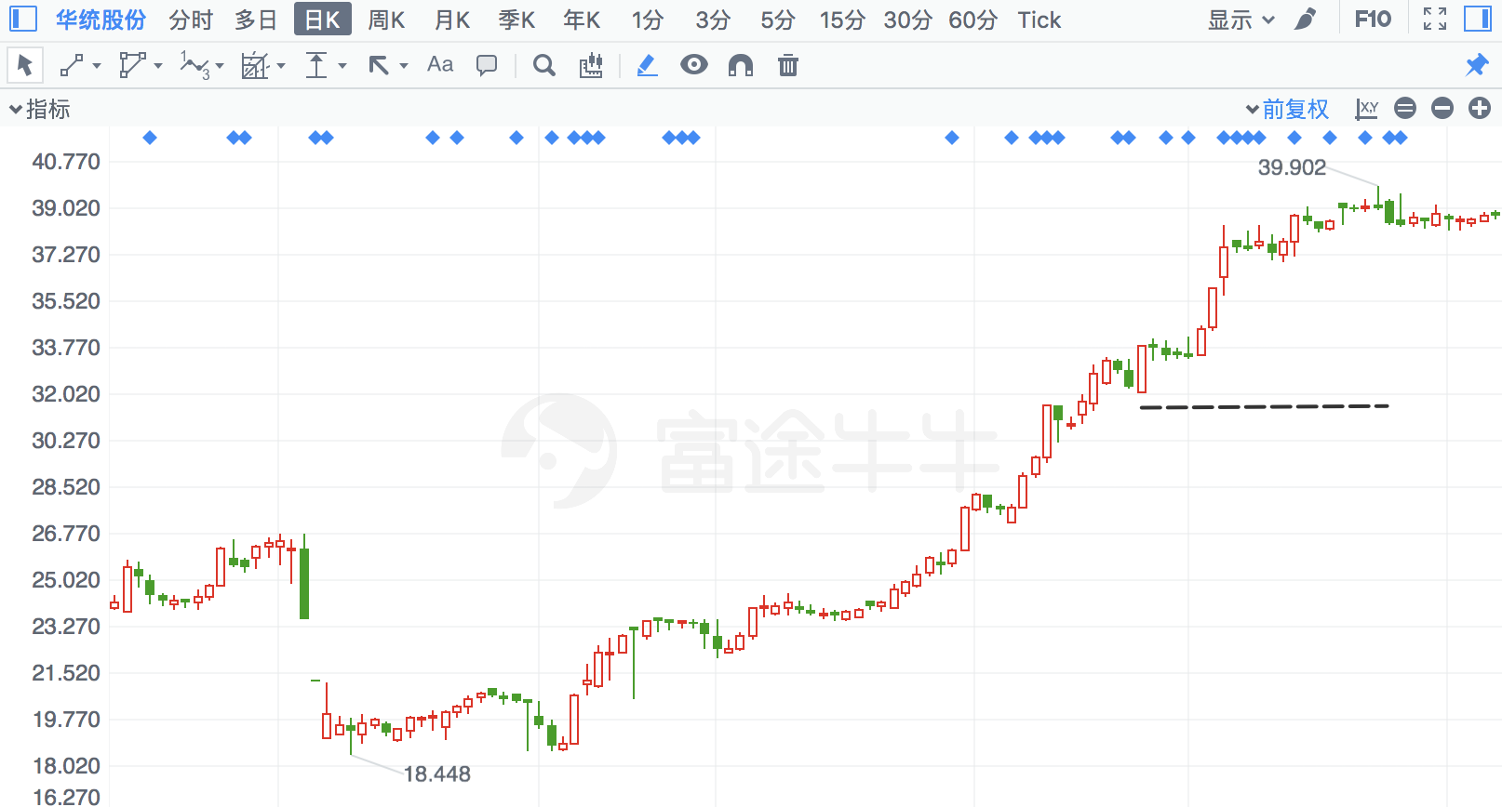

## 复旦复华

|  |  |  |  |
| --- | --- | --- | --- |
| 2017/7/18 | 600624 | 复旦复华 | **10.79%** |

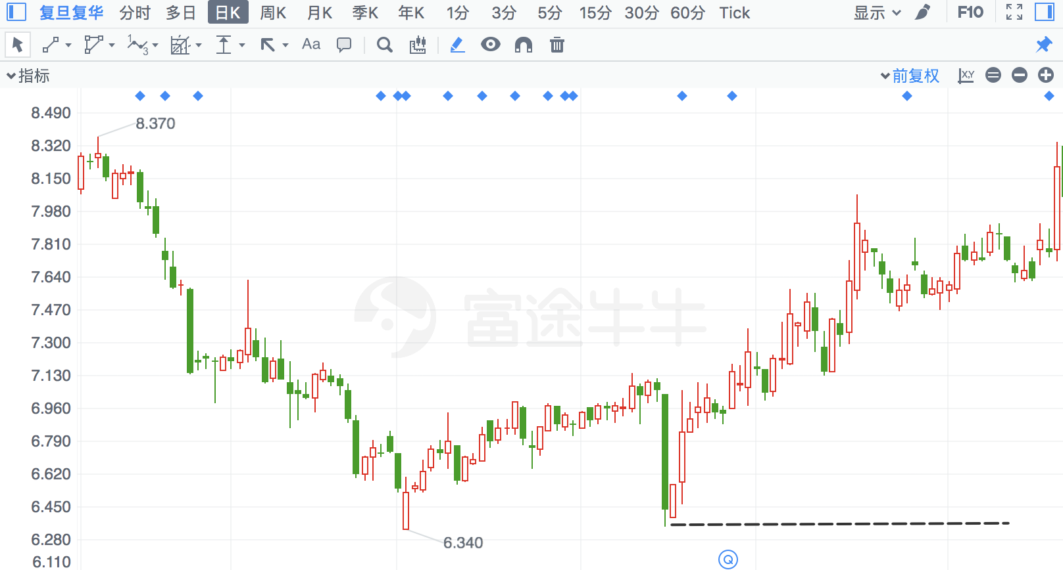

## 长源电力

|  |  |  |  |
| --- | --- | --- | --- |
| 2017/8/14 | 966 | 长源电力 | **10.68%** |

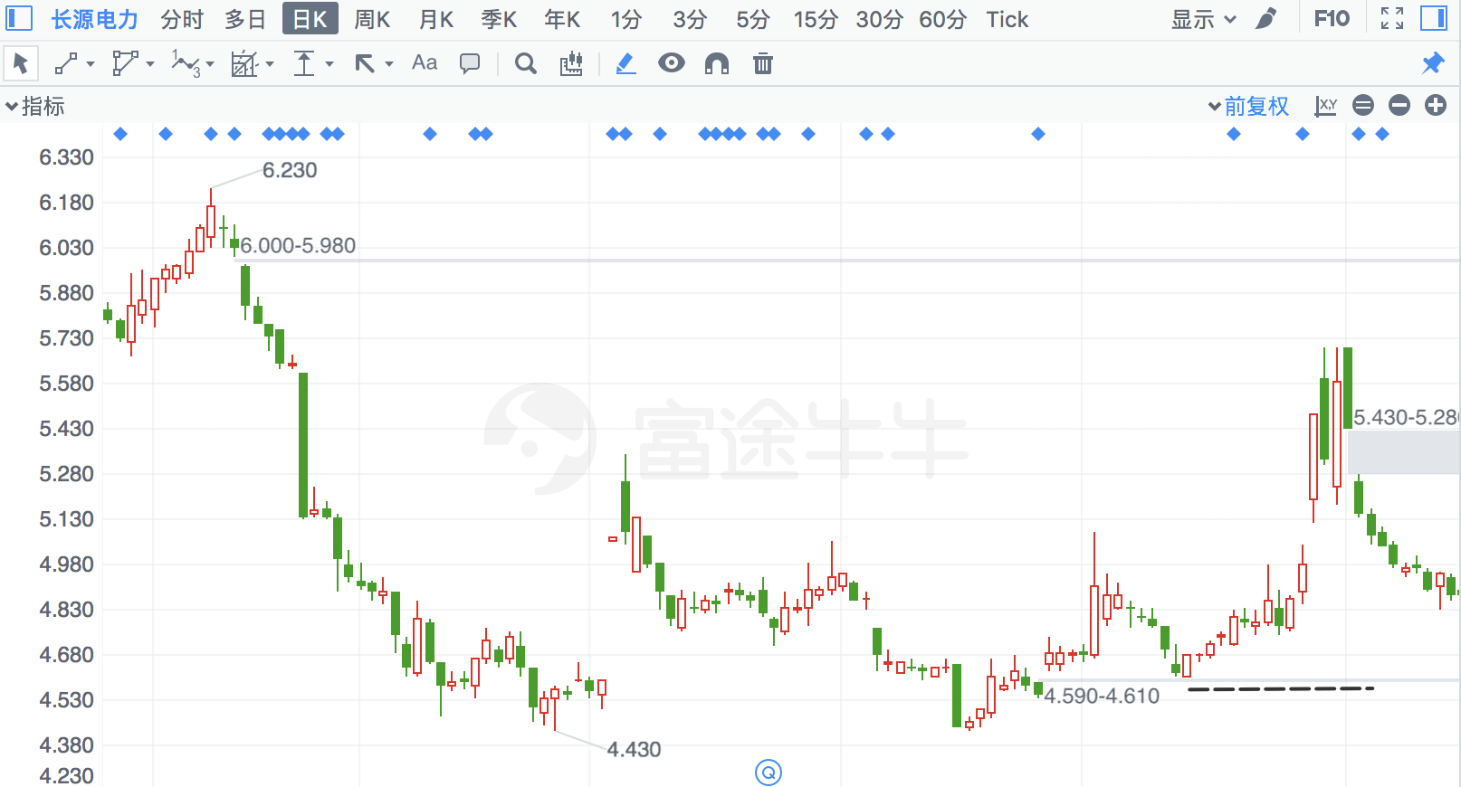

## 万里股份

|  |  |  |  |
| --- | --- | --- | --- |
| 2018/3/1 | 600847 | 万里股份 | **10.49%** |

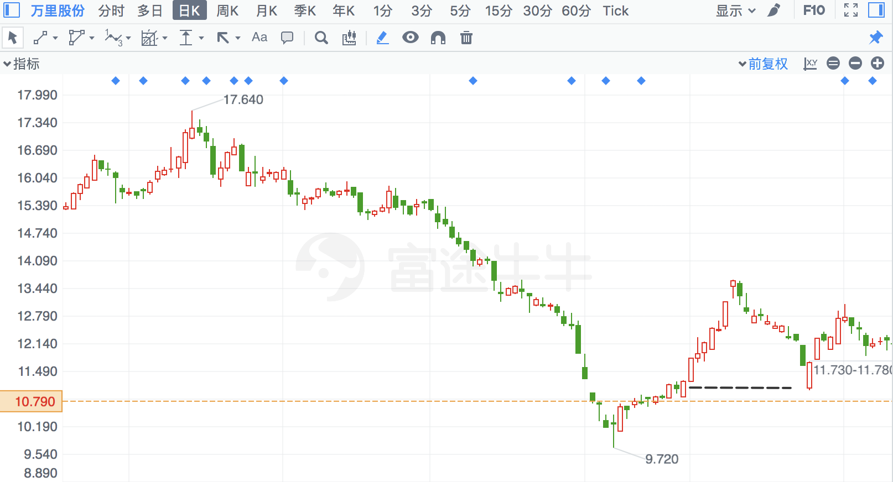

## 乐山电力

|  |  |  |  |
| --- | --- | --- | --- |
| 2017/12/13 | 600644 | 乐山电力 | **10.49%** |

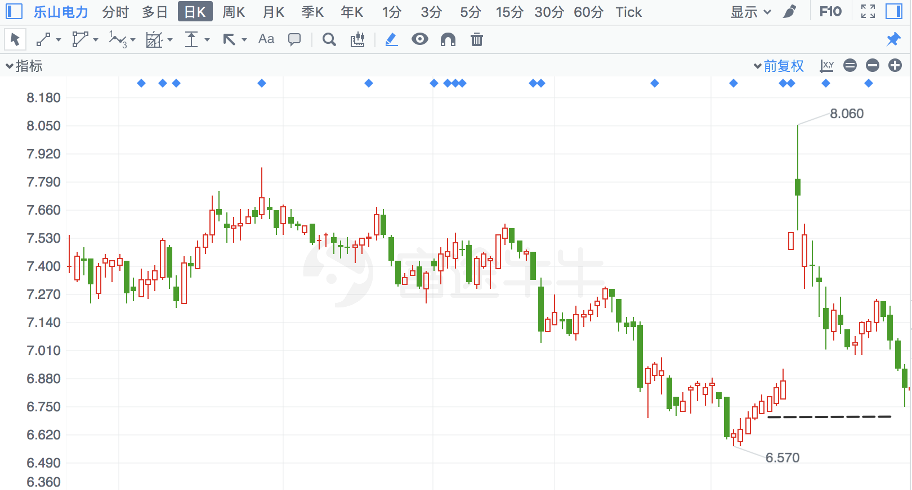

## *ST金宇

|  |  |  |  |
| --- | --- | --- | --- |
| 2018/2/12 | 803 | *ST金宇 | **10.32%** |

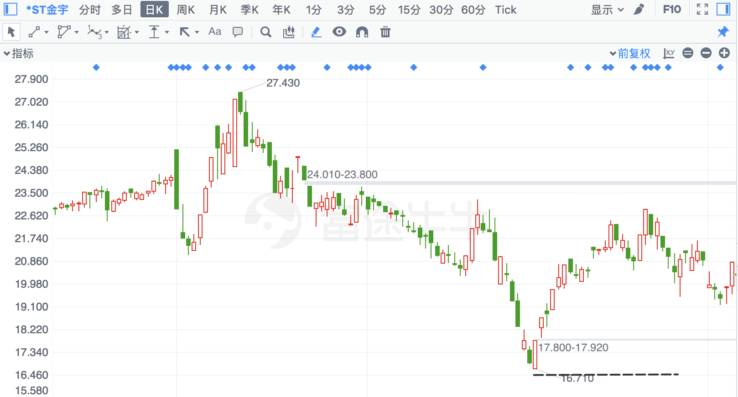

## 弘信电子

|  |  |  |  |
| --- | --- | --- | --- |
| 2017/10/31 | 300657 | 弘信电子 | **10.25%** |

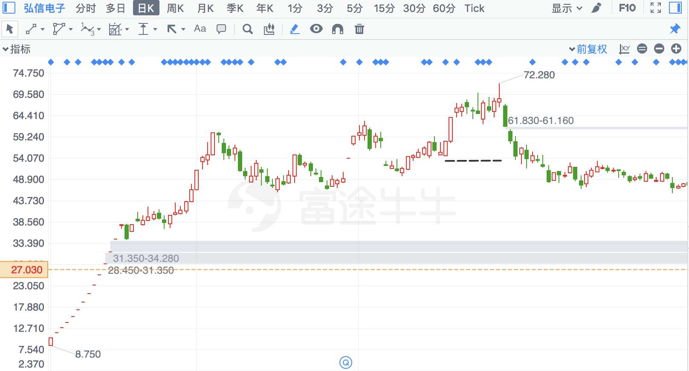

## *ST中基

|  |  |  |  |
| --- | --- | --- | --- |
| 2018/2/14 | 972 | *ST中基 | **10.15%** |

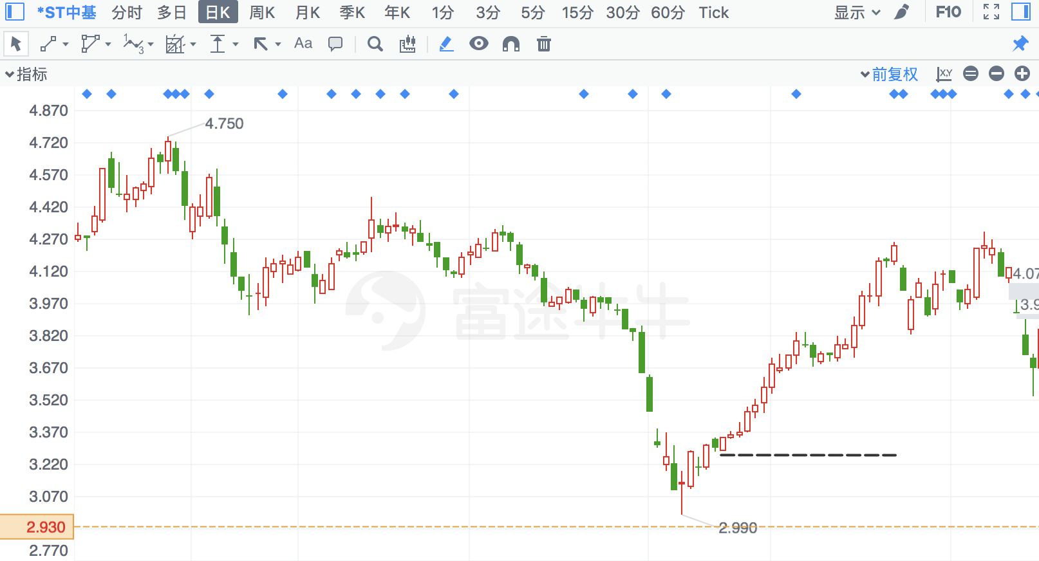

# 亏损超过5%

## *ST华信

ST涨4.9%，等于涨停

|  |  |  |  |
| --- | --- | --- | --- |
| 2018/5/24 | 2018 | *ST华信 | **-9.72%** |

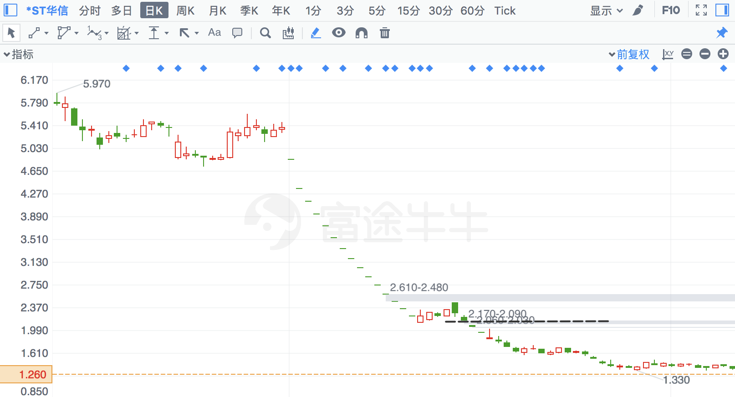

## *ST尤夫

ST涨5%，等于涨停

|  |  |  |  |
| --- | --- | --- | --- |
| 2018/6/20 | 2427 | *ST尤夫 | **-8.66%** |

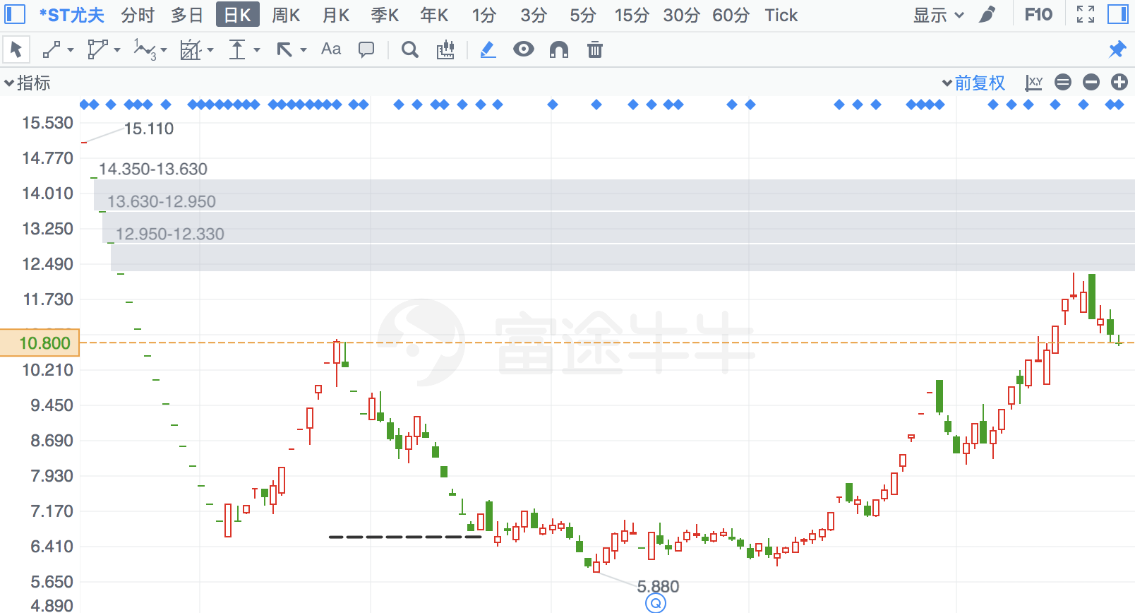

## 一汽夏利

|  |  |  |  |
| --- | --- | --- | --- |
| 2016/12/9 | 927 | 一汽夏利 | **-8.66%** |

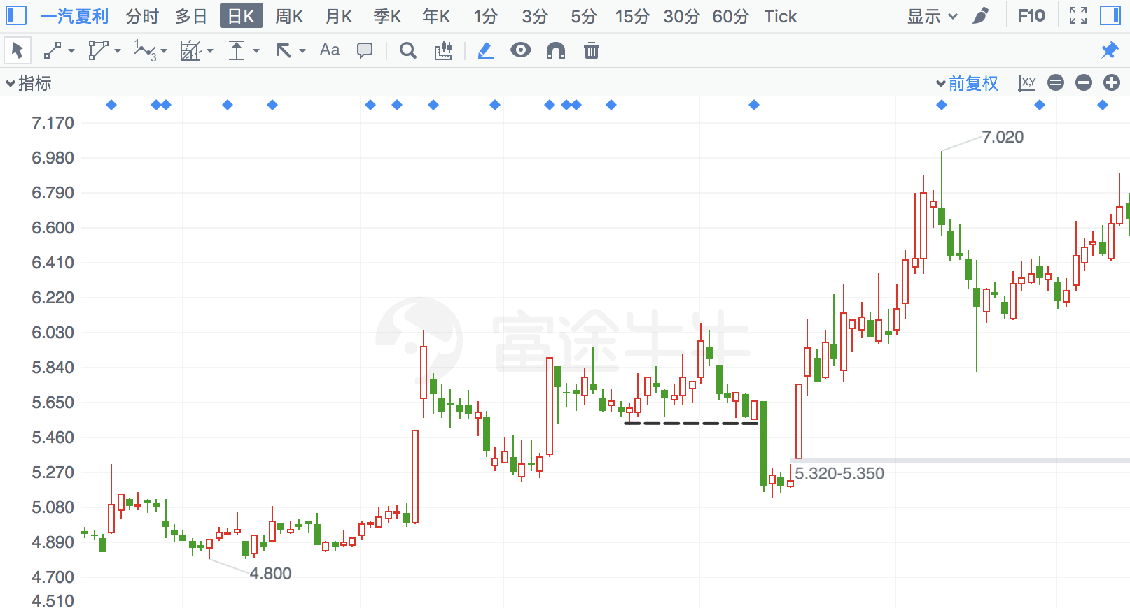

## 国科微

|  |  |  |  |
| --- | --- | --- | --- |
| 2018/3/20 | 300672 | 国科微 | **-8.29%** |

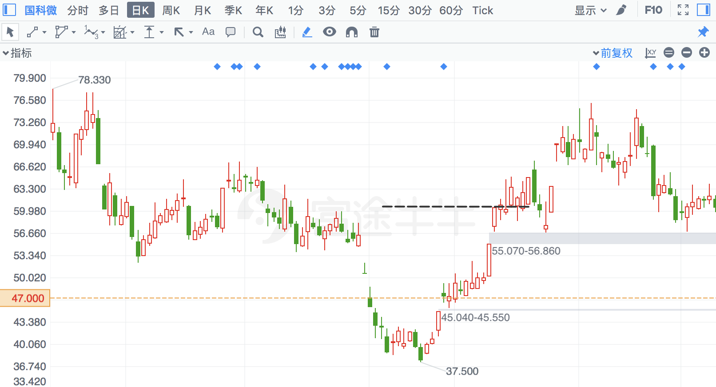

## *ST金岭

ST涨4.9%，等于涨停

|  |  |  |  |
| --- | --- | --- | --- |
| 2018/8/22 | 655 | *ST金岭 | **-7.99%** |

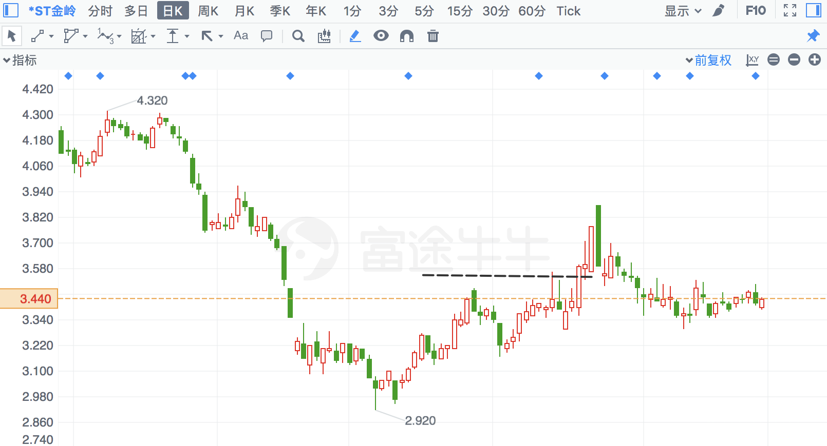

## 开元股份

|  |  |  |  |
| --- | --- | --- | --- |
| 2018/4/25 | 300338 | 开元股份 | **-7.74%** |

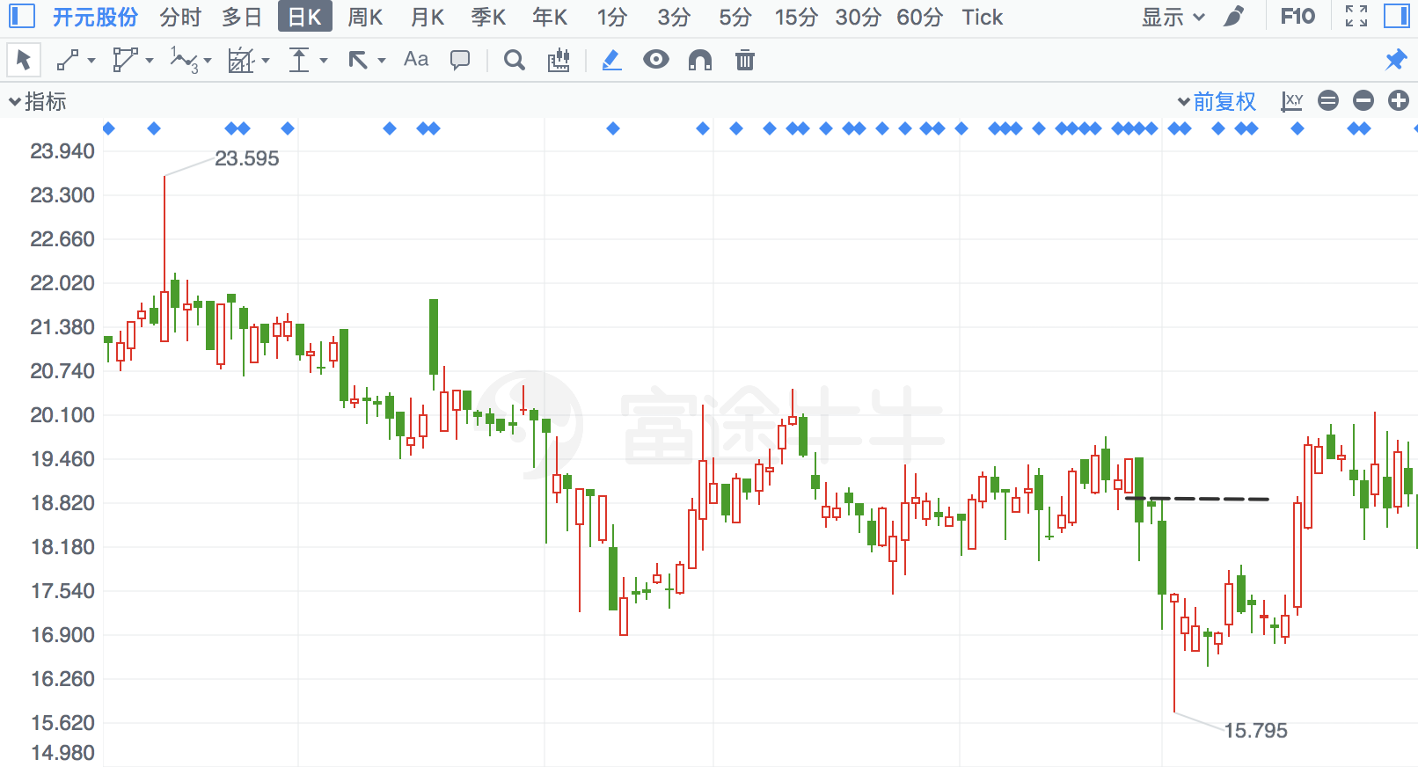

## 中国重汽

|  |  |  |  |
| --- | --- | --- | --- |
| 2018/6/29 | 951 | 中国重汽 | **-7.25%** |

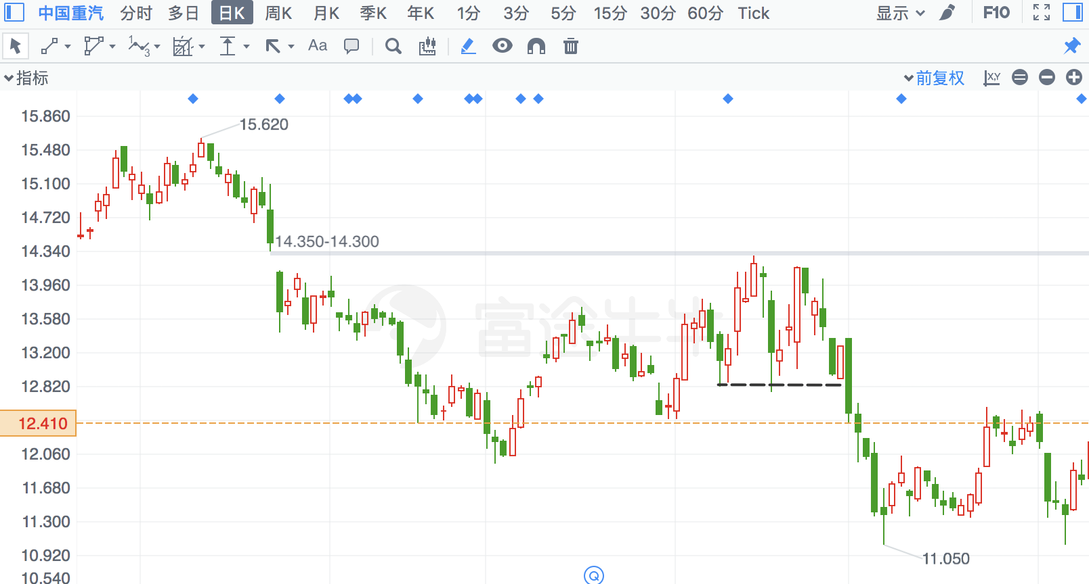

## 银河磁体

|  |  |  |  |
| --- | --- | --- | --- |
| 2017/8/7 | 300127 | 银河磁体 | **-7.02%** |

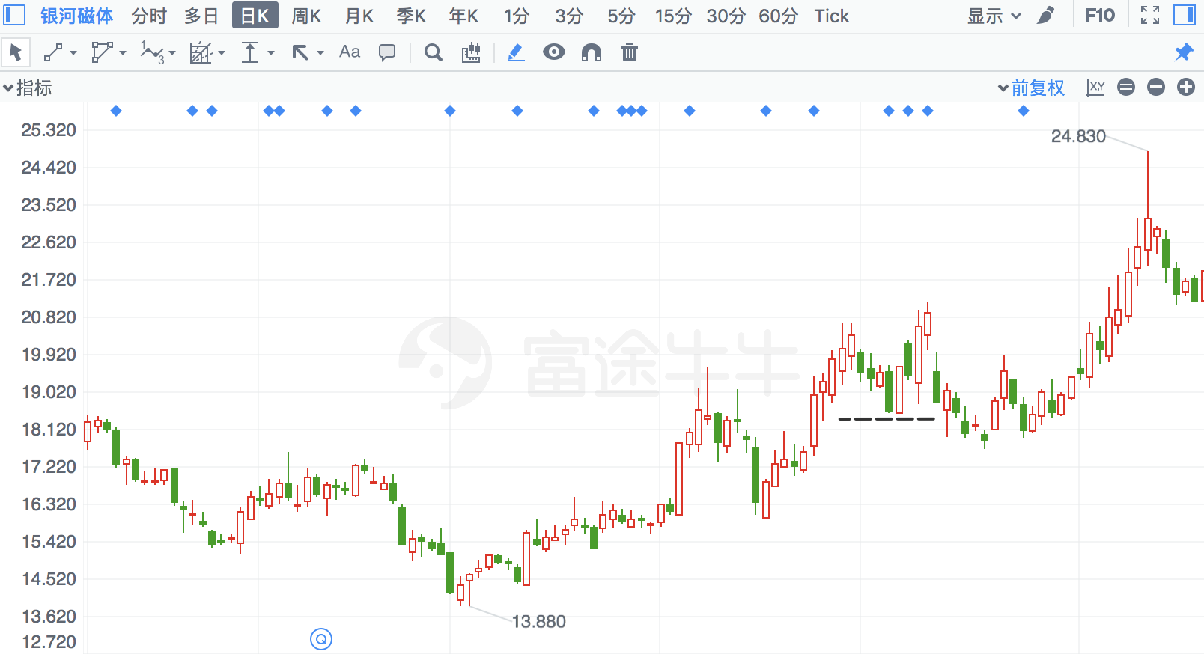

## 中孚信息

|  |  |  |  |
| --- | --- | --- | --- |
| 2018/6/22 | 300659 | 中孚信息 | **-6.72%** |

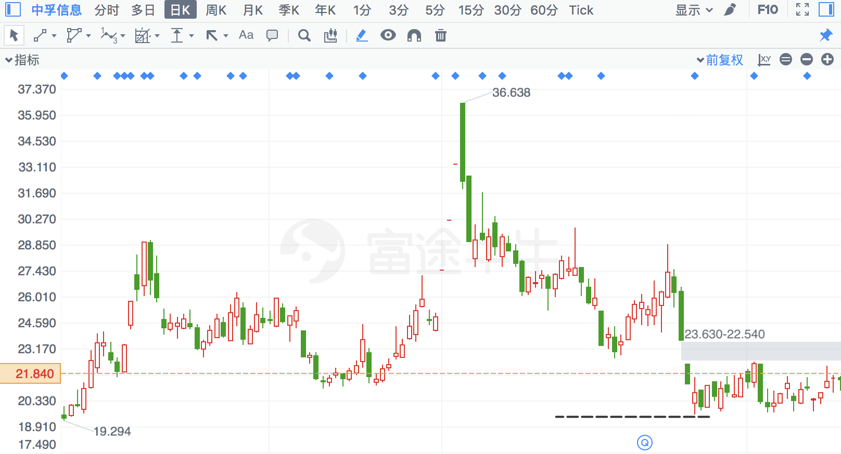

## 北讯集团

|  |  |  |  |
| --- | --- | --- | --- |
| 2017/3/30 | 2359 | 北讯集团 | **-6.66%** |

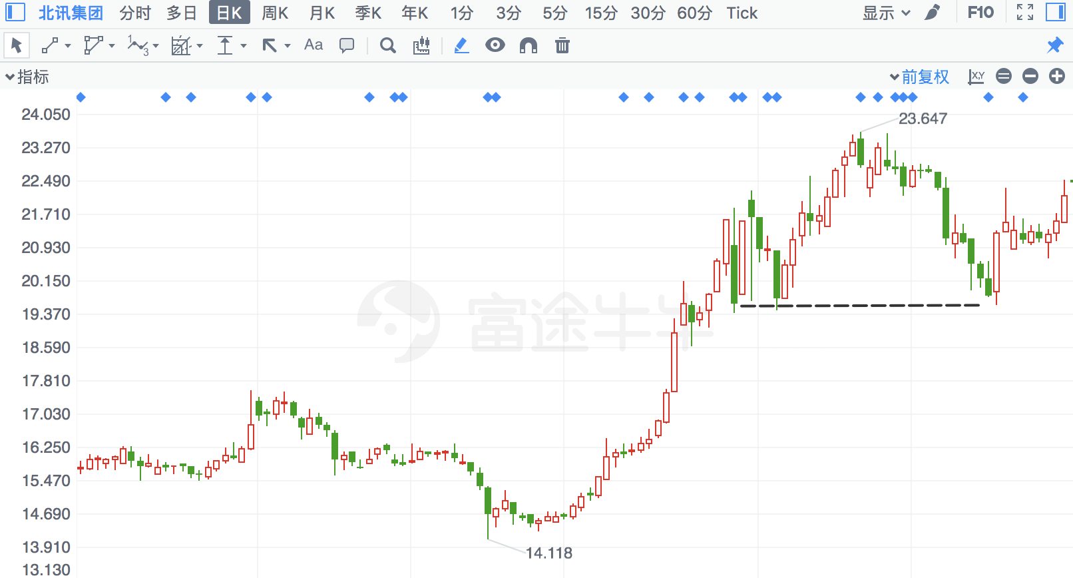

## 郑州煤电

|  |  |  |  |
| --- | --- | --- | --- |
| 2017/9/6 | 600121 | 郑州煤电 | **-6.62%** |

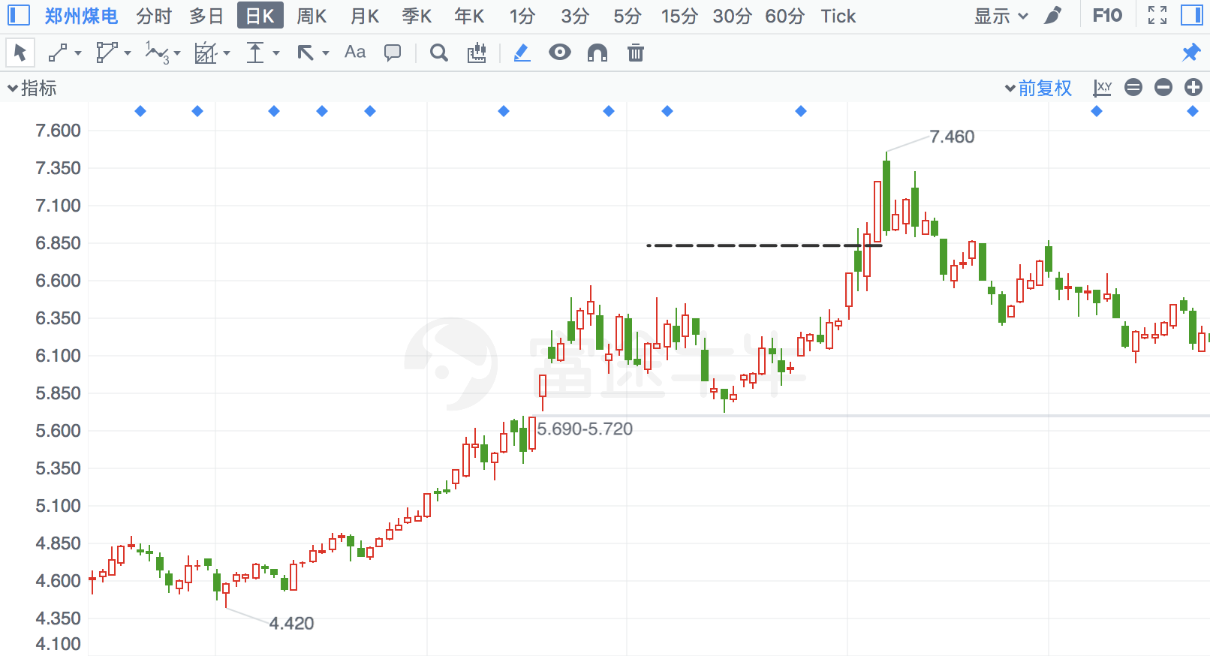

## 中原特钢

|  |  |  |  |
| --- | --- | --- | --- |
| 2017/1/9 | 2423 | 中原特钢 | **-6.51%** |

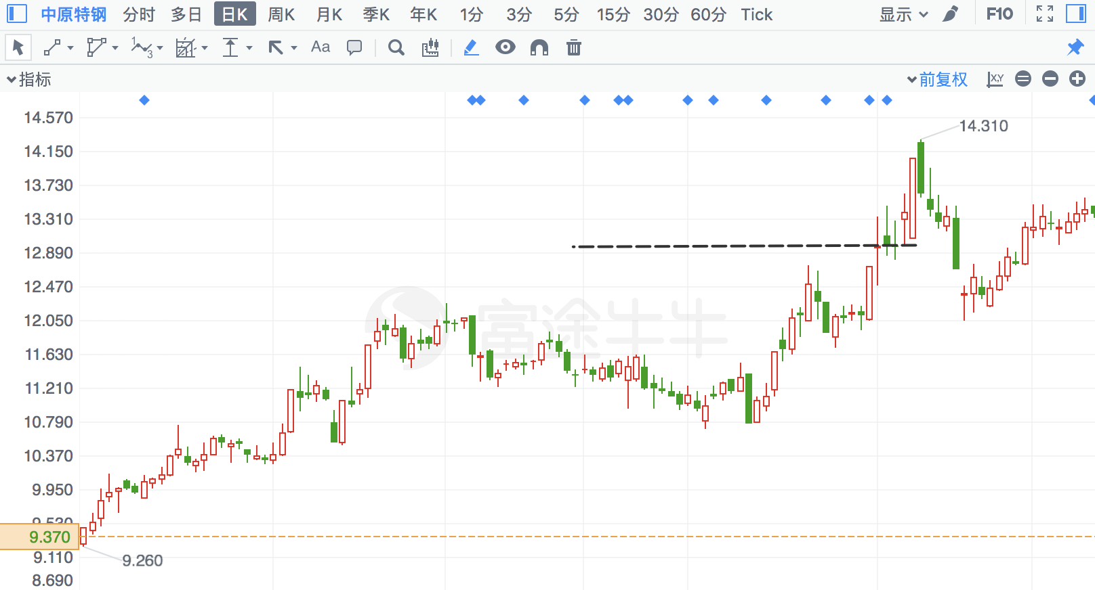

## 广宇发展

|  |  |  |  |
| --- | --- | --- | --- |
| 2017/10/31 | 537 | 广宇发展 | **-6.36%** |

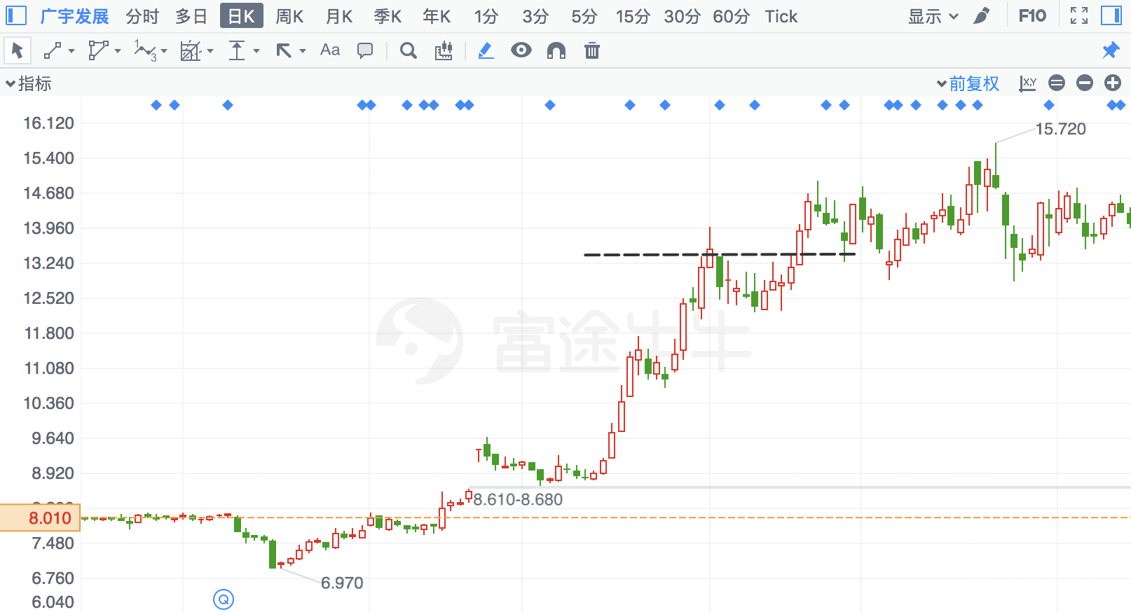

## 中油资本

曹明成老师的原话：光头光脚阳线，且相对前日缩量，成交量在5日均量线之下，**股价处于日、周线图上涨初、中期。**

|  |  |  |  |
| --- | --- | --- | --- |
| 2016/9/30 | 617 | 中油资本 | **-6.13%** |

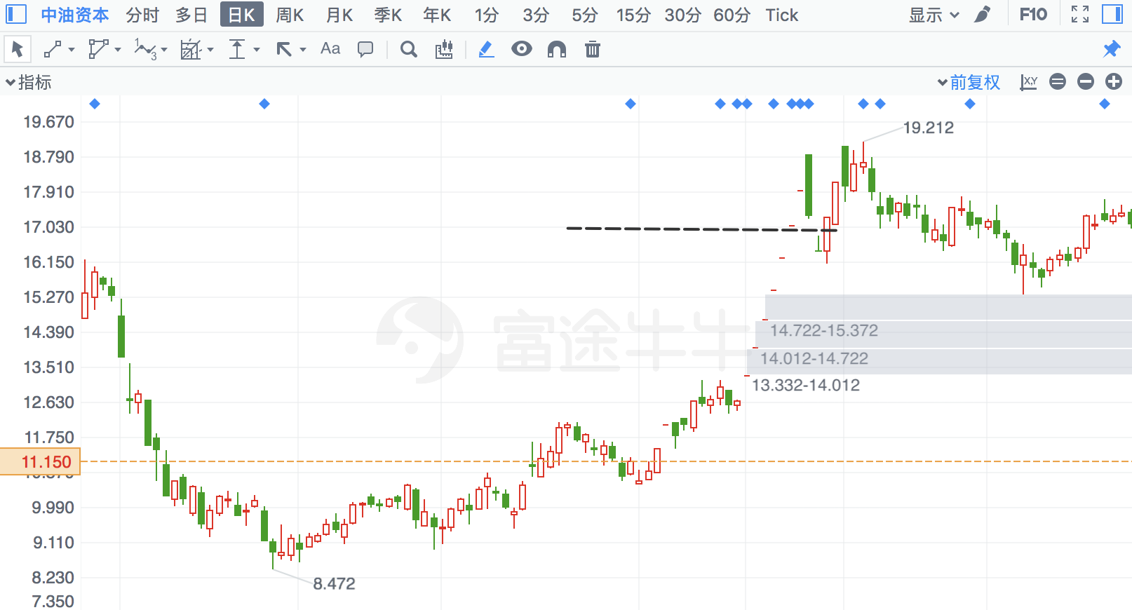

## 南都电源

|  |  |  |  |
| --- | --- | --- | --- |
| 2017/4/13 | 300068 | 南都电源 | **-6.09%** |

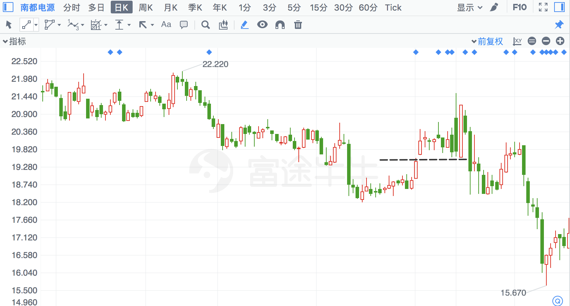

## 寒锐钴业

昨日涨停

|  |  |  |  |
| --- | --- | --- | --- |
| 2017/9/19 | 300618 | 寒锐钴业 | **-5.50%** |

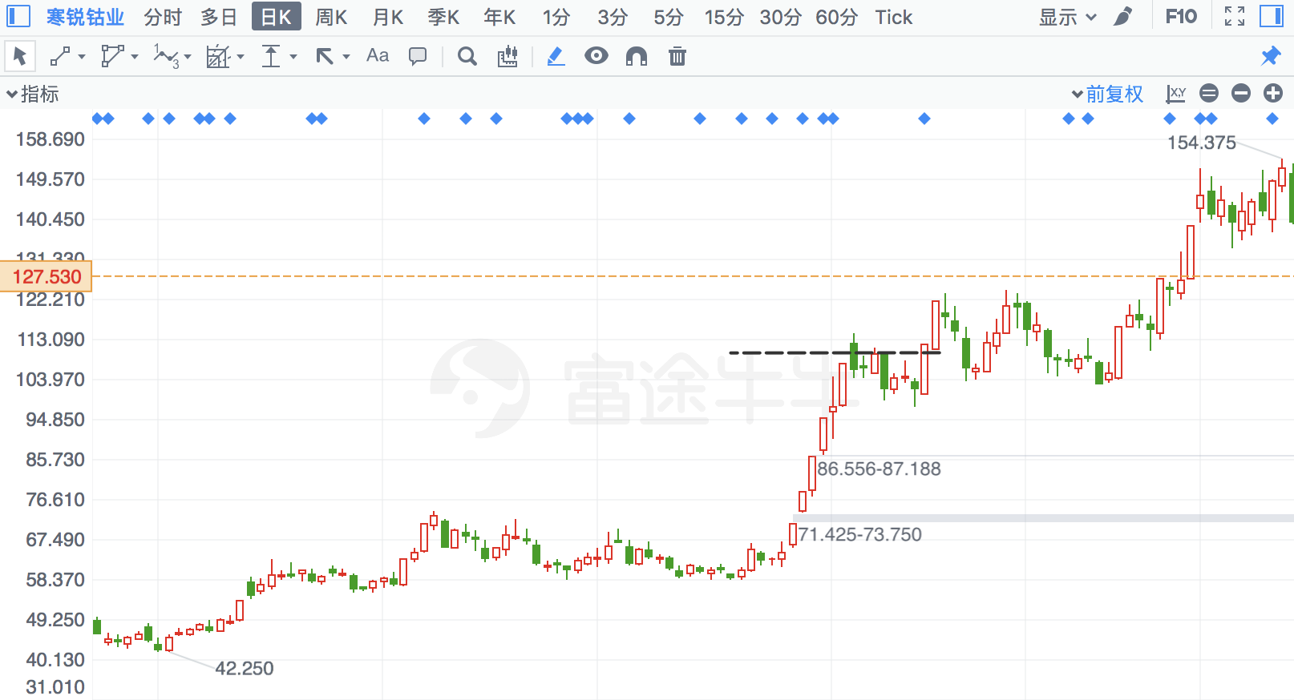

## 双一科技

|  |  |  |  |
| --- | --- | --- | --- |
| 2017/8/31 | 300690 | 双一科技 | **-5.43%** |

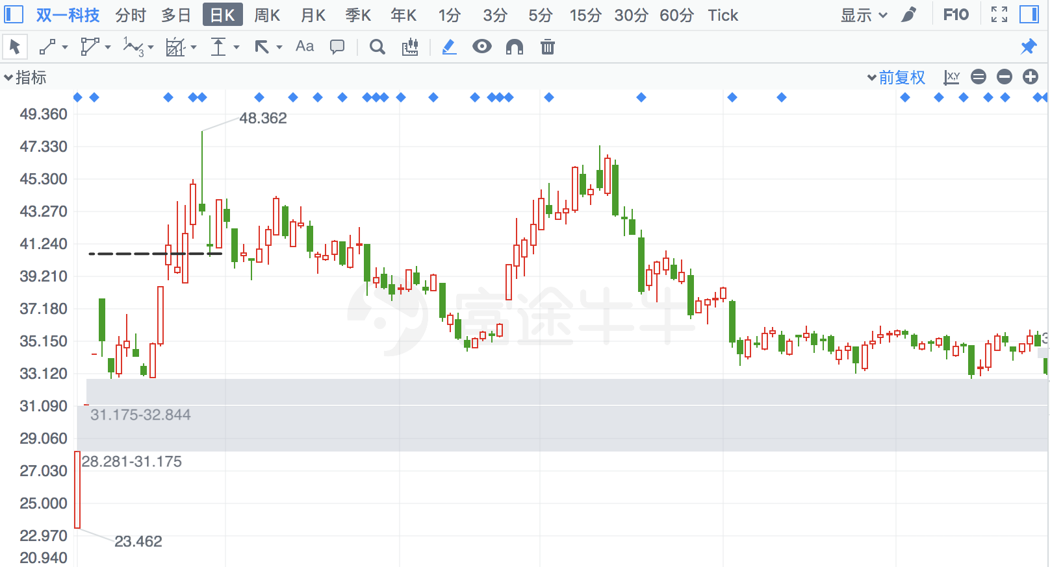

## 沈阳机床

|  |  |  |  |
| --- | --- | --- | --- |
| 2018/2/5 | 410 | 沈阳机床 | **-5.37%** |

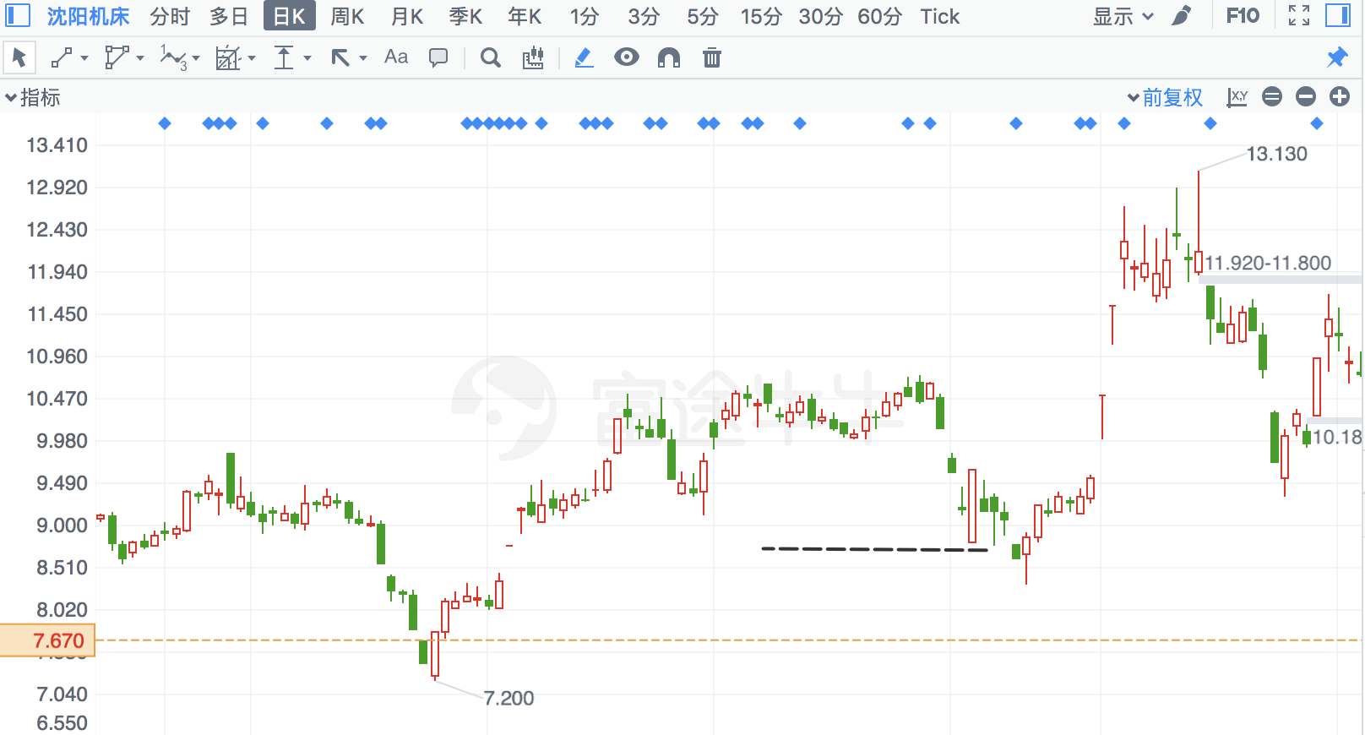

## 南京聚隆

|  |  |  |  |
| --- | --- | --- | --- |
| 2018/8/9 | 300644 | 南京聚隆 | **-5.35%** |

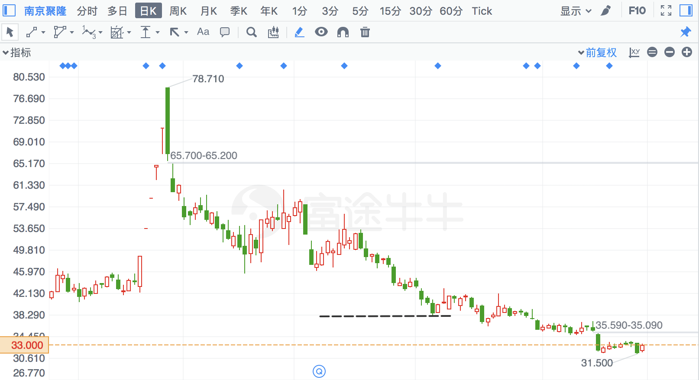

## 京运通

|  |  |  |  |
| --- | --- | --- | --- |
| 2017/11/28 | 601908 | 京运通 | **-5.31%** |

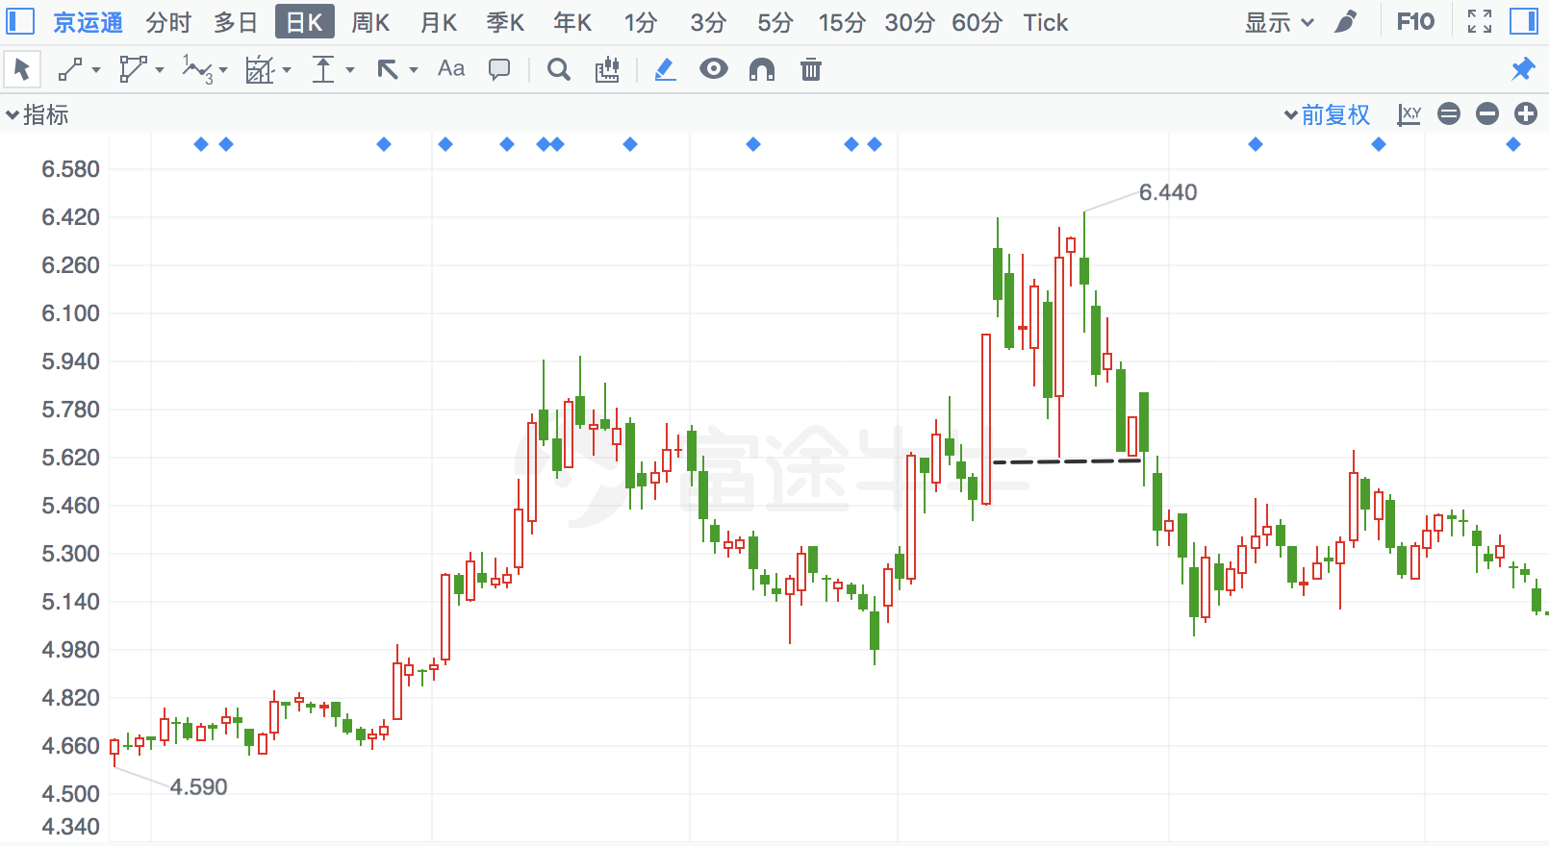

## 金风科技

|  |  |  |  |
| --- | --- | --- | --- |
| 2018/8/7 | 2202 | 金风科技 | **-5.30%** |

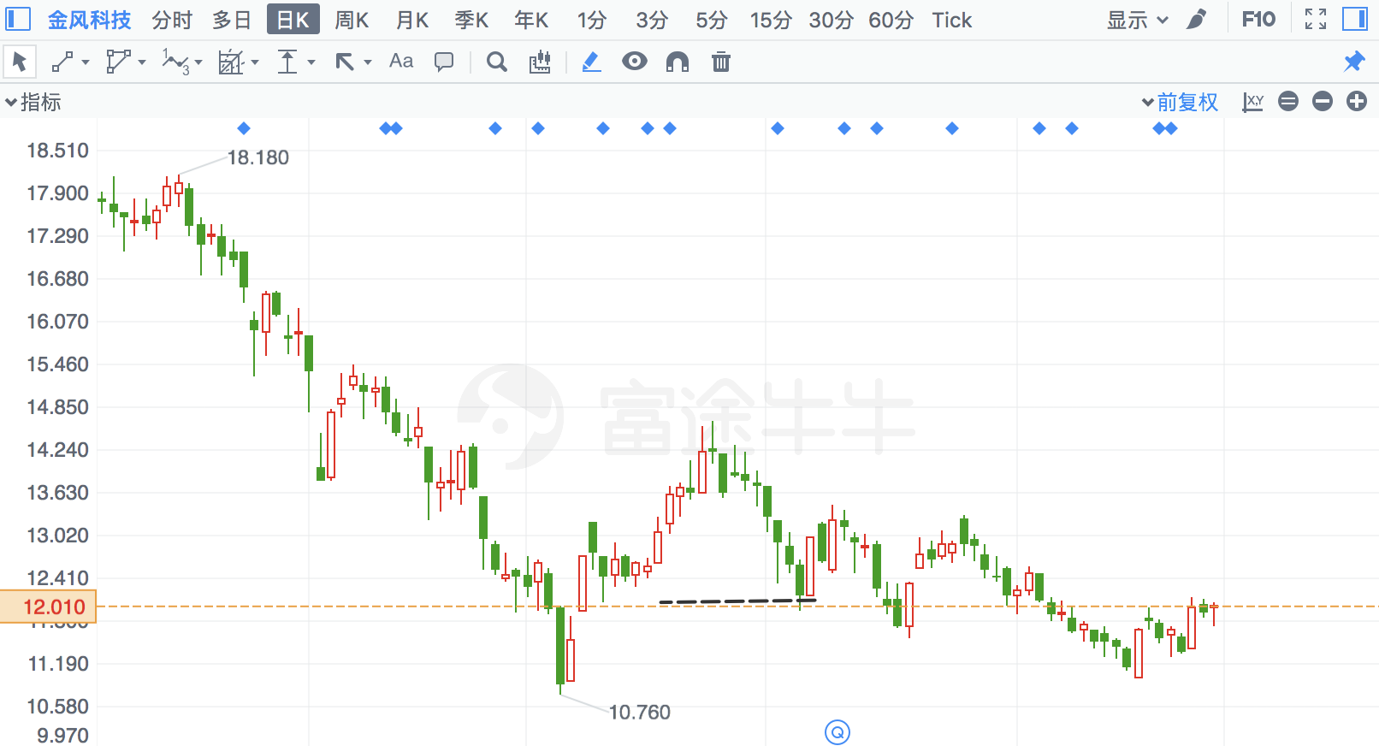

## 台海核电

|  |  |  |  |
| --- | --- | --- | --- |
| 2017/12/1 | 2366 | 台海核电 | **-5.23%** |

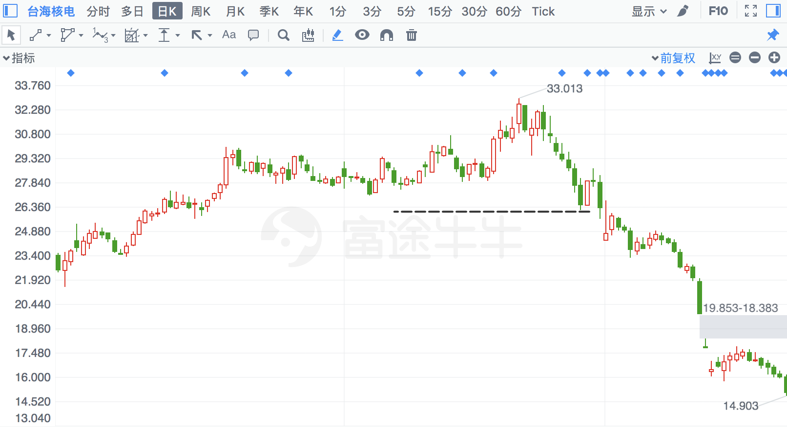

## 易世达

|  |  |  |  |
| --- | --- | --- | --- |
| 2016/9/8 | 300125 | 易世达 | **-5.20%** |

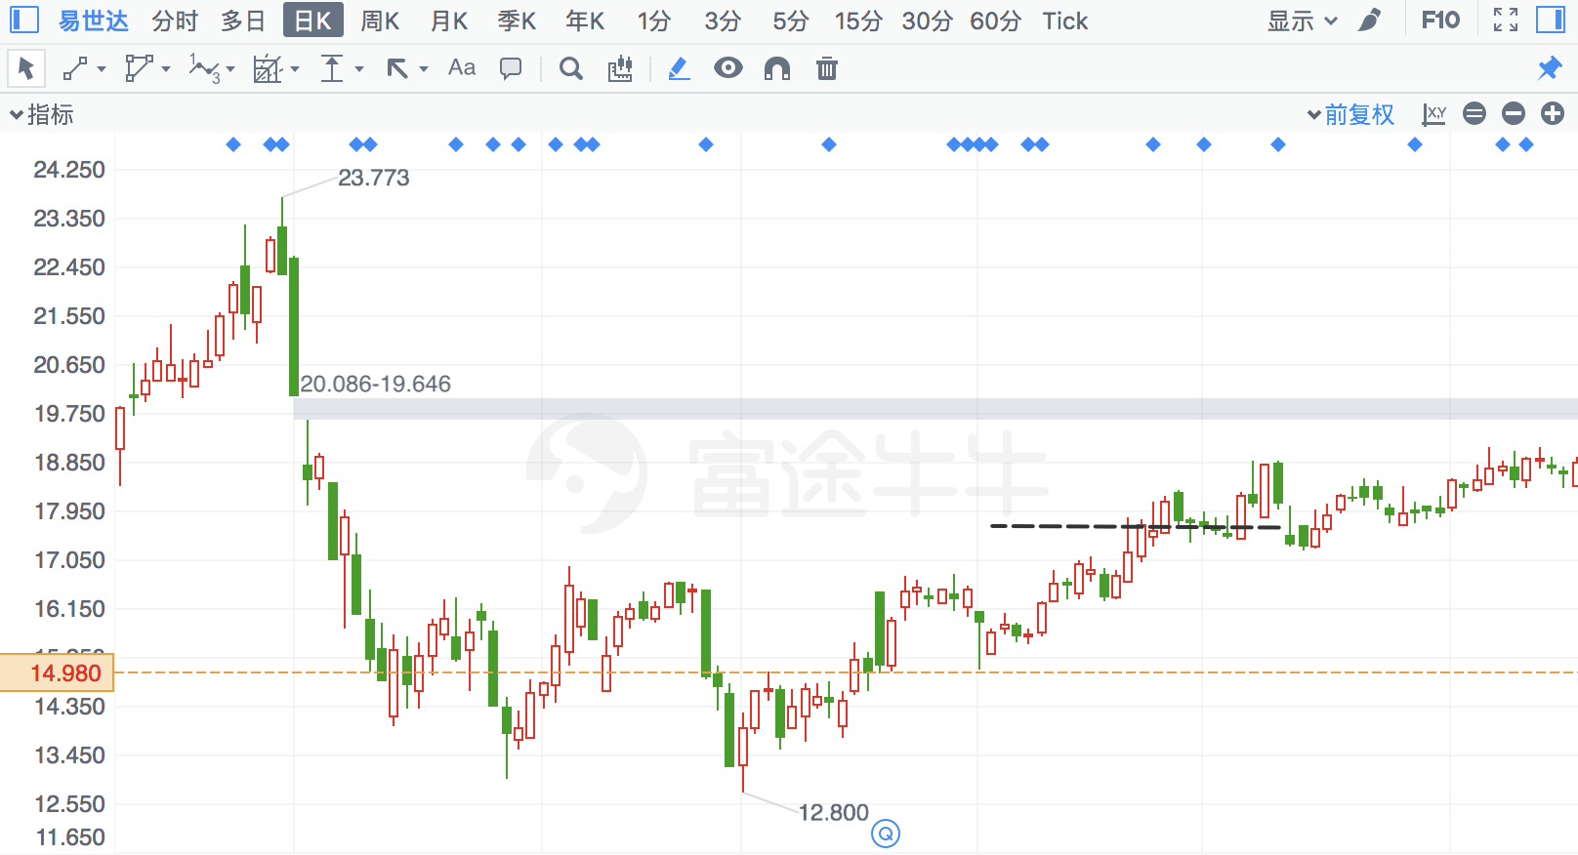

## 三德科技

|  |  |  |  |
| --- | --- | --- | --- |
| 2017/11/24 | 300515 | 三德科技 | **-5.19%** |

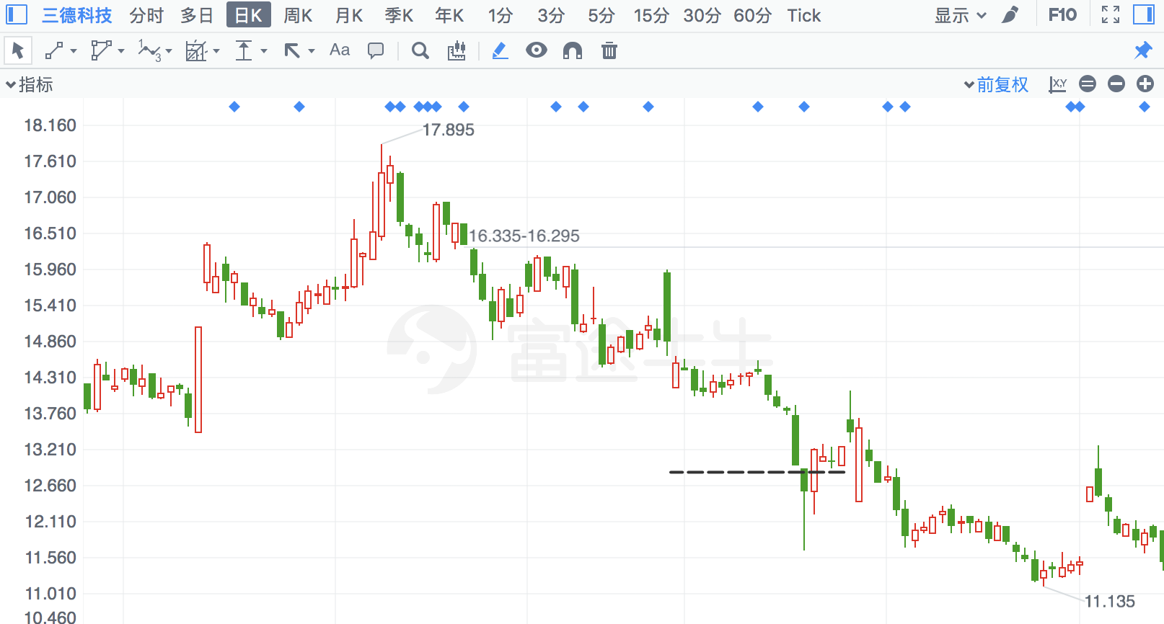

## 顺鑫农业

|  |  |  |  |
| --- | --- | --- | --- |
| 2018/4/19 | 860 | 顺鑫农业 | **-5.17%** |

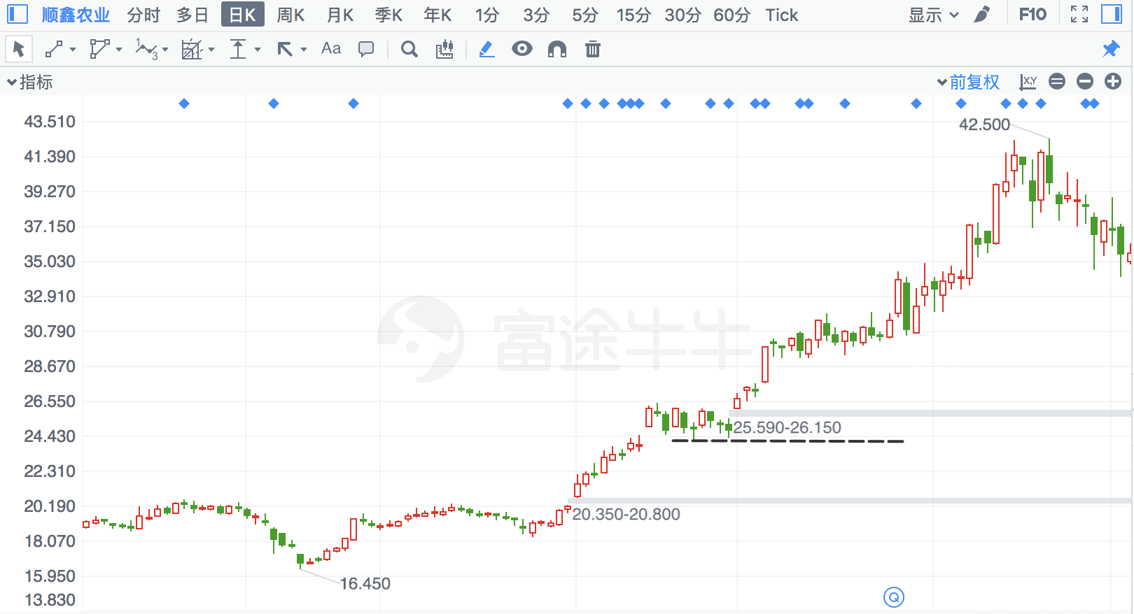

## 汇洁股份

|  |  |  |  |
| --- | --- | --- | --- |
| 2018/7/31 | 2763 | 汇洁股份 | **-5.17%** |

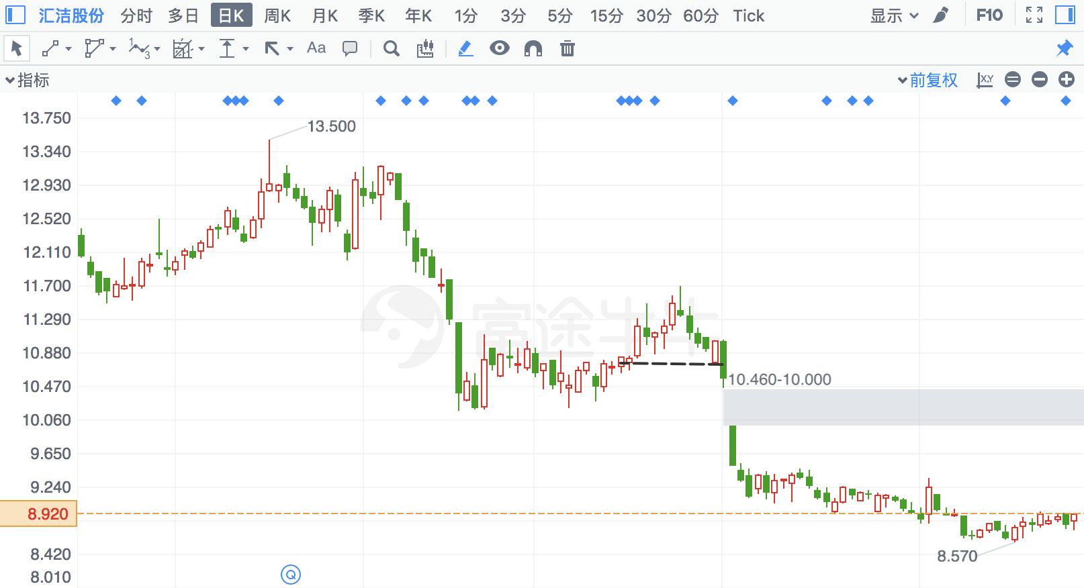

## 中来股份

|  |  |  |  |
| --- | --- | --- | --- |
| 2018/1/30 | 300393 | 中来股份 | **-5.14%** |

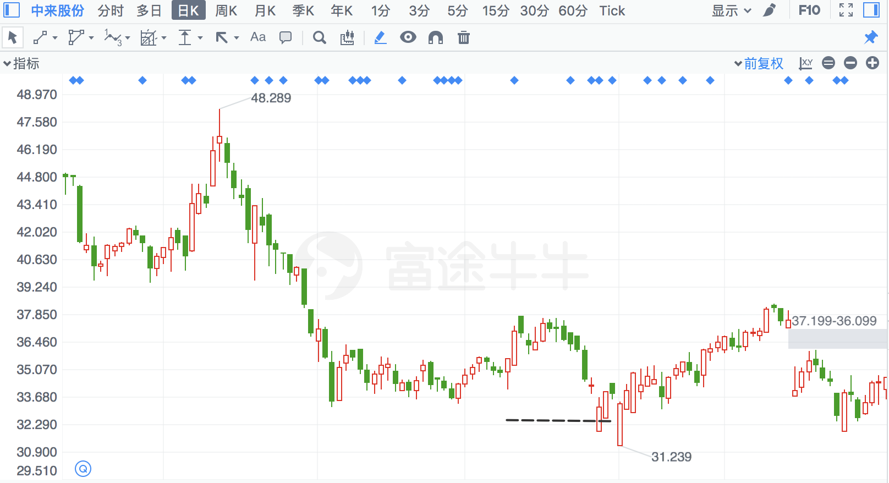

## 长盈精密

|  |  |  |  |
| --- | --- | --- | --- |
| 2018/7/17 | 300115 | 长盈精密 | **-5.10%** |

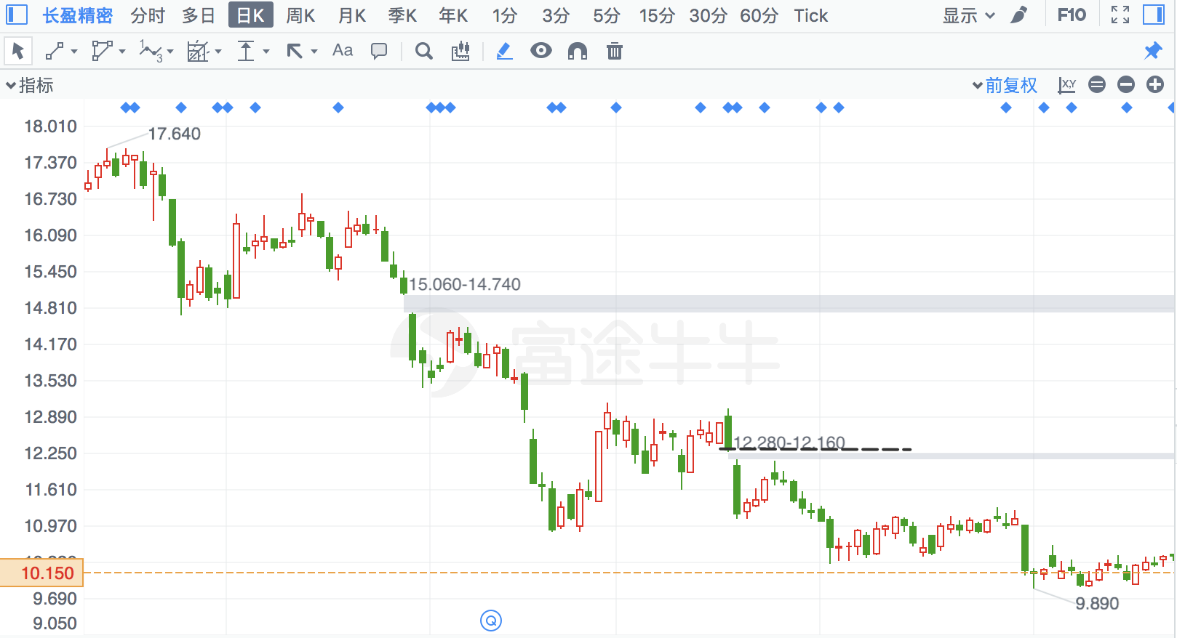

## 桂林三金

|  |  |  |  |
| --- | --- | --- | --- |
| 2018/2/5 | 2275 | 桂林三金 | **-5.03%** |

